**AIRLINE RESERVATION**

**A Mini Project Report Submitted In Partial Fulfilment of the Requirement for the Award of the Degree Of**

**BACHELOR OF COMPUTER SCIENCE**

**Submitted By**

**U.YASHWANTH (Reg.No:222208268)**



Under The Guidance of

**Mrs S. SUMATHY, M.Sc. MPhil.,**

**KUMARARANI MEENA MUTHAIH COLLEGE OF ART & SCIENCE**

**(Affiliated To University of & Reaccredited By NAAC)**

No: 4, Crescent Avenue Road Gandhi Nagar, Adyar, Chennai-600 020.

**2024 – 2025**

### KUMARARANI MEENA MUTHAIH COLLEGE OF ART & SCIENCE

### (Affiliated To University of & Reaccredited By NAAC)

No: 4, Crescent Avenue Road Gandhi Nagar, Adyar, Chennai-600 020

**BONAFIED CERTIFICATE**

This is to certify that the project report entitled “**WEB APPLICATION”** is the bonafide record of work done **U.YASHWANTH** (**Reg.No: 222208268)** in partial fulfilment for the award of the degree of Bachelor of Science in computer science during the academic year 2024 – 2025.

**Name and Signature of the Guide** **Head of the Department**

**Submitted for the viva-voce examination on: _______________________**

**Examiners:**

**1.**

**2.**

# **AKNOWLEDGEMENT**

At the outset, we would like to express our sincere gratitude to the ALMIGHTY and our beloved secretary& correspondent Mr. M.A.M.R Muthiah., for her constant guidance and support to the student community and the Society.

We would like to express our hearty thanks to our respected principal, Dr.P.T.Vijayashree, M.A.,Ph.D., M.B.A., for her kind encouragement and blessings.

We would like to acknowledge our gratitude to our guide Mrs. S. SUMATHY, M.Sc. MPhil., Assistant professor for her excellent guidance and connoisseur’s Suggestion the study carried out successfully

Mrs. A. SHEELA, MCA. MPhil., Assistant professor, Head, Department of Computer Science,

Mrs. R.SHEELA KUMARI, MCA. MPhil., Assistant professor. We thank the Faculty Members and our Family, who helped and encouraged us constantly to complete the project successfully

**INDEX**

|  |  |  |
| --- | --- | --- |
| **sno** | **CONTENT** | **PAGENO** |
| **1.** | **Abstractions** |  |
| **2.** | **Introduction** |  |
| **3.** | **SYSTEM REQUIREMENT**  Software Requirements  Hardware Requirements |  |
| **4.** | **SYSTEM ANALYSIS**  Existing System  Proposed System |  |
| **5.** | **SYSTEM ARCHITECTURE** |  |
| **6.** | **UML DIAGRAM** |  |
| **7.** | **ER DIAGRAM** |  |
| **8.** | **SYSTEM TESTING** |  |
| **9.** | **DASHBOARD** |  |
| **10.** | **CODING** |  |
| **11.** | **DATABASE** |  |
| **13.** | **A VISUAL REPRESENTAION OF WEBSITE** |  |
| **14.** | **CONCLUSION** |  |
| **15.** | **APPLICATION AND FUTURE ENHANCEMENT** |  |

**ABSTRACT**

The Airport Authority System (AAS) was one of the earliest changes to improve efficiency. ARS eventually evolved into the Computer Reservations System (CRS), and then into Global Distribution System (GDS). The airline industry created the first GDS in the 1960s as a way to keep track of flight schedules, availability, and prices. Although accused of being “dinosaurs” due to their use of legacy system technology, GDSs were actually among the first e-commerce companies in the world facilitating B-2-B electronic commerce as early as the mid 1970s, when SABRE (owned by American Airline) and Apollo (United) began installing their propriety internal reservations systems in travel agencies. Prior to this, travel agents spent an inordinate amount of time manually entering reservations. The airlines realized that by automating the reservation process for travel agents, they could make the travel agents more productive and essentially turn into an extension of the airline’s sales force.

**INTRODUCTION**

In order for airports to be successful in today’s competitive air transportation market, airport owners and operators need to align their management information systems to optimize operations, improve product distributions, improve customer relations, reduce overhead, and increase revenues. A proper classification is a prerequisite to systems alignment. Research on the intersection of the areas of aviation and management of information systems is scarce. The purpose of this paper is to contribute to the body of knowledge by providing descriptions of airport management information systems, their interoperability with other systems, and the key uses and users of each system. There are many types of management information systems and they can be organized or classified in a number of different ways. Furthermore, each system may or may not be necessary for a particular airport depending on the business goals and objectives and the certificate which the airport is operating under. Consequently, the system classification schema presented in this paper is neither all-inclusive nor exclusive; however, a number of leading aviation practitioners, business professionals, and educators in the industry were instrumental in both proposing and validating the schema. The study used interviews, documentation, and observation as the primary sources of data. This paper is concerned with key Airside Management Information Systems. Airside Management Information Systems facilitate the airport and airline operations required to process aircraft, passengers, and air cargo. They involve the ticketing of air travelers, ground movement of aircraft and vehicles, flight procedures of aircraft within airport airspace, and scheduling and managing of boarding and gate equipment, and weather updates. The airside management information systems covered in this paper are: Gate Management System, Aircraft Fuelling System, Air Traffic Control (ATC) System, Weather Monitoring System, Airfield Lighting System, and Automatic Vehicle Identification (AVI) System.

**LITERTURE SURVEY:**

AUTHOR: Abisoye Blessing, 2012

TITLE: Challenges of Airline Reservation System and Possible Solutions (A Case Study of Overland Airways)

DESCRIPTION:

An Airline Reservation system is very important because it has the strong ability to reduce errors that might have occurred when using a manual system of reservation and helps speed up the boarding process. Overland Airways has an existing Airline Reservation System, but this paper analyzed the problems of the existing system. The problems are: inability of passengers to select their preferred seat(s) from the reservation system, No option of passengers printing their boarding pass from the existing system, non-notification of passengers of flight cancellation or delays and passengers don‘t have access to aircraft maintenance report to ease the fears associated with air travel and its disasters. In this paper, an Improved Airline Reservation System that is convenient for passengers to solve the aforementioned problems was designed. The Improved Airline Reservation system is designed and implemented using data obtained from interviewing airline personnel, passengers, and materials on Airline Reservation Systems. In this regard, the Improved Airline Reservation System will assist Overland Airways in variety of airline administration tasks and service needs from time of initial reservation through completion of the task. The following programming languages were used: PHP, JavaScript, HTML and CSS for designing the interface of the system, and SQL for the database. The designed airline system was tested with 50 passengers.

2.AUTHOR: John R. Knight,1972

TITLE: A case study: Airlines reservations systems

DESCRIPTION:

The historical development of airlines reservations systems is traced. Characteristics are defined which are those of any real-time, conversational, highly interactive system. The structure of the system is described--agent terminal area, communications facilities, and central site. Lessons learned in the design, development, testing, implementation, and tuning of two generations of systems are discussed. These discussions include initial system design, simulations and systems measurement tools, systems stability and reliability, serial processing, parallel- or multiprocessors, split front-end back-end processing, storage hierarchy, standard and special communications disciplines, and flexibility versus performance. Unlike batch processing the real-time system cannot simply take more run time for a job that has been underestimated. It may well not be able to perform the job at all. Design of these systems is as much an art based on experience as a science and is an iterative process. Systems now being installed have capacities of 180 messages/s, accommodate 10 000 terminals which have access to a 10 billion-byte data base, and provide response times of less than 3s.

3.AUTHOR: Anuradha Prajapati,2018

TITLE: A systematic review on online airline reservation system

DESCRIPTION:

As the innovation advancements are immediately created including mobile innovation, a web application for reservation services can upgrade people's life, make it less complex. This looks into presents a reservation system for airline organizations to rearrange the way toward booking a flight. The clients, as a rule, purchase their ticket manually furthermore, perhaps hold up in a line to check the required flight. In this paper, we presented a survey on airline reservation system. The proposed system executed to conquer manual system issue by making a booking from home or somewhere else and save time and effort.

4.AUTHOR: Chavare Dnyaneshvaree

TITLE: Flight Reservation System

DESCRIPTION:

The airline industry is characterized by rapid change, innovation and new technology. It is a dynamic growth industry which archives millions of dollars each year. My focus is on the factors that enter into determining a fare rate, whether domestic or international. Two broader terms are used when we talk about these factors that are“cost of service” and “value of service”. The first one is easy to get as it says that airline should only have to charge against its services and by value of service it means that a career should charge what the traffic will bear. Fare rates are determined by a complex interaction of both cost of service and value of service.

The project aims to develop an airline reservation system which will provide customers a facility to reserve their tickets without any hassle. It’s a web based system developed using current software industry standards which gives its users most of the online the secondary aim of this project develop a pricing algorithm for my application based on the current pricing system which airlines are using and the factors which impact these pricing systems.

5.AUTHOR: Thembo Jimmy

TITLE: An Online airline reservation information system

DESCRIPTION:

Airline Reservation Systems (ARS) used to be standalone systems. Each airline had its own system, disconnected from other airlines or ticket agents, and usable only by a designated number of airline employees. Travel agents in the 1970s pushed for access to the airlines' systems. Today, air travel information is linked, stored, and retrieved by a network of Computer Reservations Systems (CRS), accessible by multiple airlines and travel agents. This report is a summary of the study that was undertaken to design and implement an airline reservation system. The airline reservation system designed in this project was developed using php, java script and html as the programming languages and Mysql asthe database Management system. The researcher reviewed the literature of reservation systems in chapter two and explored the advantages and limitations of reservation system in real life situations. The researcher used interviews and questionnaire methods during the data collection phase, these data collection methods helped the researcher to better understand the existing system in use. Case tools and data flow diagram were used during the development process to simulate the process of airline reservation and ticket booking. The outcome of the study was an online airline reservation system tested and implemented in the case study Rwenzori Airlines to book, schedule and reserve flights.

**SYSTEM REQUIREMENT**

**SOFTWARE REQUIREMENT:**

|  |  |
| --- | --- |
| **Operating System** | Windows 10 |
| **Coding Language** | JAVA |
| **Front End** | Net Beans Software |
| **Back End** | MySQLyog Community 32 |

**HARDWARE** **REQUIREMENT:**

|  |  |
| --- | --- |
| **Processor** | Intel(R) Core(TM) i5-7300U CPU @ 2.60GHz 2.71 GHz |
| **Ram** | 8.00 GB |
| **Storage** | 237GB (Hard disk) |
| **System type** | 64-bit Operating System,  x64-based processor |
| **Network** | Stable internet connection |

**SYSTEM ANALYSIS**

### EXISTING SYSTEM:

Traditional airline ticket booking systems rely on manual processes, where passengers have to visit physical counters or contact travel agents to book their flights. This outdated approach poses several challenges:

**Disadvantages:**

* **No Real-Time Updates:** Flight schedules and availability are not updated dynamically.
* **Limited Accessibility:** Customers must visit physical locations or make phone calls to book tickets.
* **Manual Data Handling:** Passenger details and flight records are managed manually, increasing the risk of errors.
* **Time-Consuming Process:** Booking and modifications require considerable time.
* **Lack of Personalization:** Users do not receive customized flight recommendations or offers.

**PROPOSED SYSTEM:**

Our airline reservation system is a comprehensive web-based platform designed to streamline flight bookings, enhance user experience, and optimize administrative operations.

**User Perspective:**

**1. Homepage Flight Search:**

* + Users can search for available flights without logging in by entering details such as departure and destination cities, travel dates, and class preferences. This feature allows potential customers to explore flight options effortlessly.​

**2**. **User Registration & Authentication:**

* + To proceed with booking, users must create an account or log in. This ensures a personalized experience and secure management of bookings.​

**3. Flight Booking Process:**

* + **Flight Selection:** After logging in, users can select their preferred flight from the available options.​
  + **Passenger Details:** Users input necessary passenger information, ensuring accuracy for ticketing and compliance purposes.​
  + **Seat Selection:** The system provides an interactive seat map, allowing users to choose their desired seats based on availability.​
  + **Payment Processing:** Secure payment gateways facilitate transactions through various methods, including credit/debit cards and digital wallets.​
  + **Ticket Issuance:** Upon successful payment, the system generates an e-ticket in PDF format, which is immediately sent to the user's registered email address.​

**Admin Perspective:**

1. **Flight Management:**
   * **Add/Update Flights:** Admins can input new flight details or modify existing ones, including schedules, destinations, and pricing.​
   * **View Flight Details:** A comprehensive dashboard displays all flights, enabling efficient monitoring and management.​
2. **Reservation Management:**
   * **View User Reservations:** Admins have access to all bookings, allowing them to assist with customer inquiries, handle special requests, and manage operational logistics.​

**Data Management:**

* **Database Integration:** All user and flight data are securely stored in a MySQL database, ensuring data integrity and facilitating efficient retrieval.​

**Key Features and Benefits:**

* **User-Friendly Interface:** The platform's intuitive design ensures a seamless experience for users, from flight search to booking completion.​
* **Real-Time Flight Availability:** Users access up-to-date information on flight options without the need for prior authentication.​
* **Secure Transactions:** Robust security protocols protect user data and payment information, fostering trust and reliability.​
* **Efficient Administrative Controls:** Admins benefit from streamlined processes for managing flights and reservations, enhancing operational efficiency.​
* **Automated Notifications:** Immediate email confirmations with e-ticket PDFs keep users informed and provide necessary travel documents promptly.

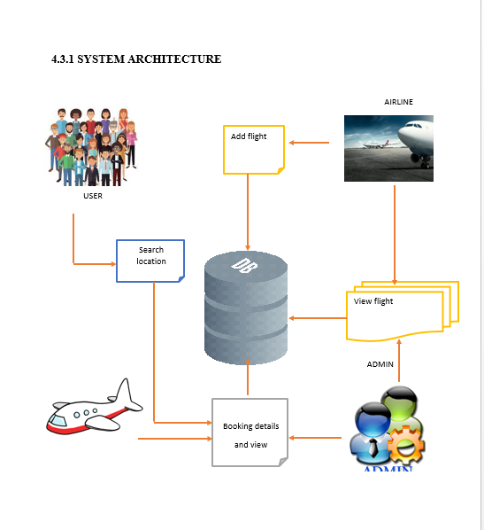**SYSTEM ARCHITECTURE**

### 

### 

### UML DIAGRAM

1. Use Case Diagram:

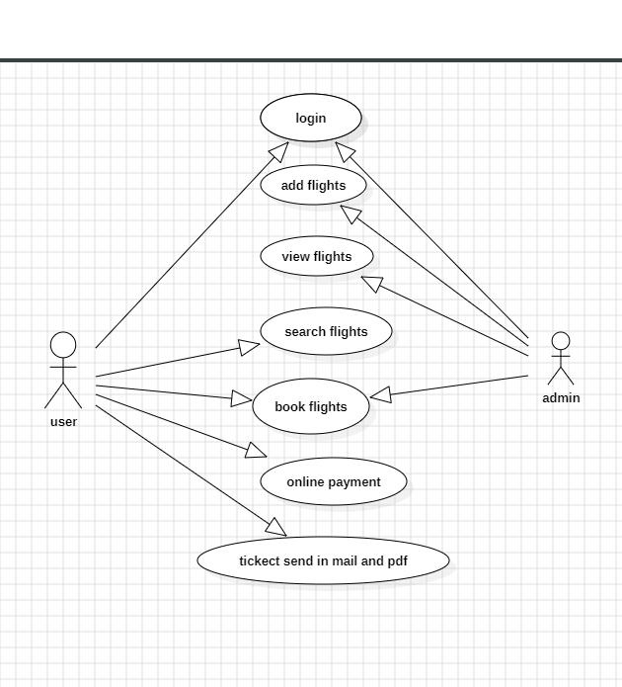

2. Class Diagram:

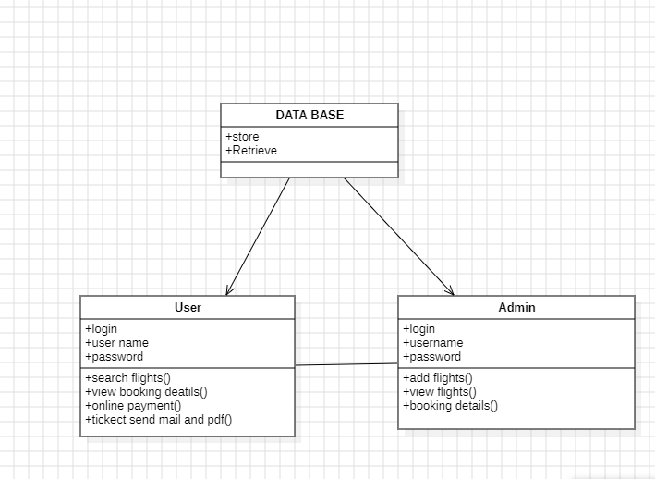

3. Sequence Diagram:

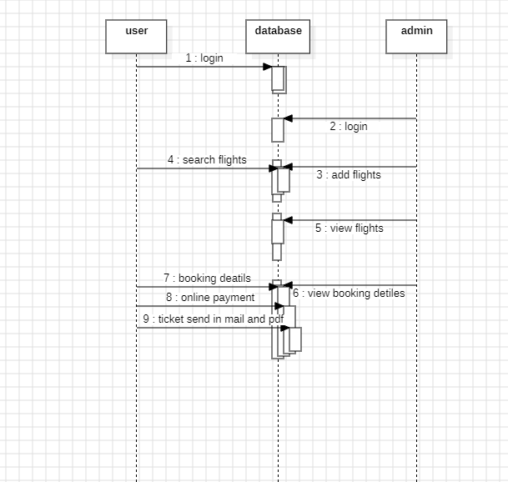

**4**. Deployment Diagram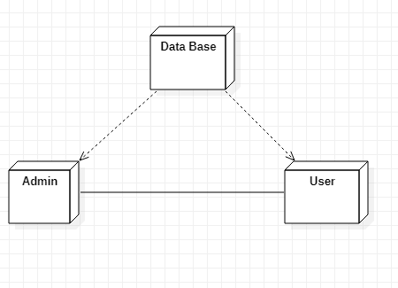

5. Data Flow Diagram:

Level 0:

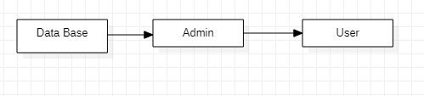

Level 1:

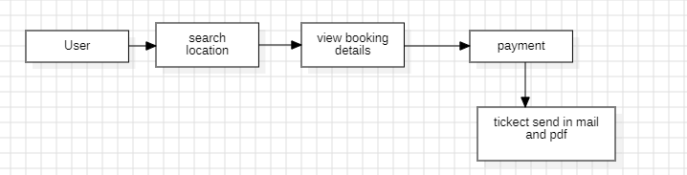

Level 2:

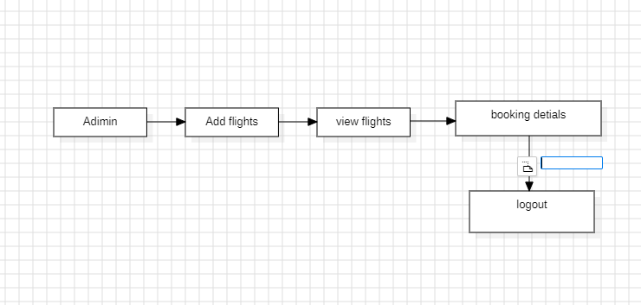

**ER DIAGRAM**

**ADMIN**

**DATABASE**

**USER**

**SYSTEM TESTING**

The purpose of testing is to discover errors. Testing is the process of trying to discover every conceivable fault or weakness in a work product. It provides a way to check the functionality of components, sub-assemblies, assemblies and/or a finished product It is the process of exercising software with the intent of ensuring that the

Software system meets its requirements and user expectations and does not fail in an unacceptable manner. There are various types of test. Each test type addresses a specific testing requirement.

**TYPES OF TESTS**

**Unit testing**

Unit testing involves the design of test cases that validate that the internal program logic is functioning properly, and that program inputs produce valid outputs. All decision branches and internal code flow should be validated. It is the testing of individual software units of the application .it is done after the completion of an individual unit before integration. This is a structural testing, that relies on knowledge of its construction and is invasive. Unit tests perform basic tests at component level and test a specific business process, application, and/or system configuration.

Unit

tests ensure that each unique path of a business process performs accurately to the documented specifications and contains clearly defined inputs and expected results.

**Integration testing**

Integration tests are designed to test integrated software components to determine if they actually run as one program. Testing is event driven and is more concerned with the basic outcome of screens or fields. Integration tests demonstrate that although the components were individually satisfaction, as shown by successfully unit testing, the combination of components is correct and consistent. Integration testing is specifically aimed at exposing the problems that arise from the combination of components.

**Functional test**

Functional tests provide systematic demonstrations that functions tested are available as specified by the business and technical requirements, system documentation, and user manuals.

Functional testing is centered on the following items:

Valid Input : identified classes of valid input must be accepted.

Invalid Input : identified classes of invalid input must be rejected.

Functions : identified functions must be exercised.

Output : identified classes of application outputs must be exercised.

Systems/Procedures: interfacing systems or procedures must be invoked.

Organization and preparation of functional tests is focused on requirements, key functions, or special test cases. In addition, systematic coverage pertaining to identify Business process flows; data fields, predefined processes, and successive processes must be considered for testing. Before functional testing is complete, additional tests are identified and the effective value of current tests is determined.

**System Test**

System testing ensures that the entire integrated software system meets requirements. It tests a configuration to ensure known and predictable results. An example of system testing is the configuration oriented system integration test. System testing is based on process descriptions and flows, emphasizing pre-driven process links and integration points.

**White Box Testing**

White Box Testing is a testing in which in which the software tester has knowledge of the inner workings, structure and language of the software, or at least its purpose. It is purpose. It is used to test areas that cannot be reached from a black box level.

**Black Box Testing**

Black Box Testing is testing the software without any knowledge of the inner workings, structure or language of the module being tested. Black box tests, as most other kinds of tests, must be written from a definitive source document, such as specification or requirements document, such as specification or requirements document. It is a testing in which the software under test is treated, as a black box. you cannot “see” into it. The test provides inputs and responds to outputs without considering how the software works.

**Unit Testing:**

Unit testing is usually conducted as part of a combined code and unit test phase of the software lifecycle, although it is not uncommon for coding and unit testing to be conducted as two distinct phases.

**Test strategy and approach**

Field testing will be performed manually and functional tests will be written in detail. **Test objectives**

* All field entries must work properly.
* Pages must be activated from the identified link.
* The entry screen, messages and responses must not be delayed.

**Features to be tested**

* . Verify that the entries are of the correct format
* No duplicate entries should be allowed
* All links should take the user to the correct page

# **Integration Testing**

Software integration testing is the incremental integration testing of two or more integrated software components on a single platform to produce failures caused by interface defects.

The task of the integration test is to check that components or software applications, e.g. components in a software system or – one step up – software applications at the company level – interact without error.

**Test Results:** All the test cases mentioned above passed successfully. No defects encountered.

**6.3 Acceptance Testing**

User Acceptance Testing is a critical phase of any project and requires significant participation by the end user. It also ensures that the system meets the functional requirements.

**Test Results:** All the test cases mentioned above passed successfully. No defects encountered.

**Dashboard**

There is currently a lot of interest in dashboard displays. Create a flexible dashboard mechanism that supports a subset of JFreeChart chart types (dials, pies, thermometers, bars, and lines/time series) that can be delivered easily via both Java Web Start and an applet.

**CODING**

* Home page

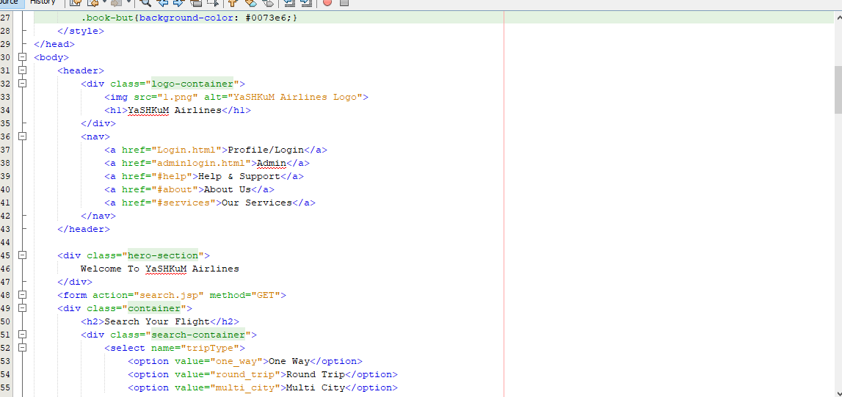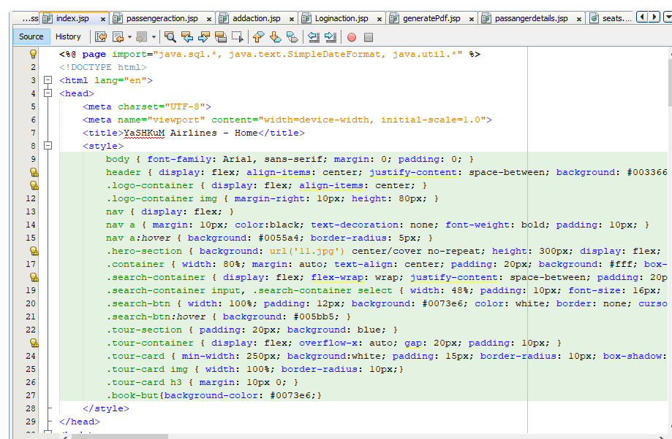

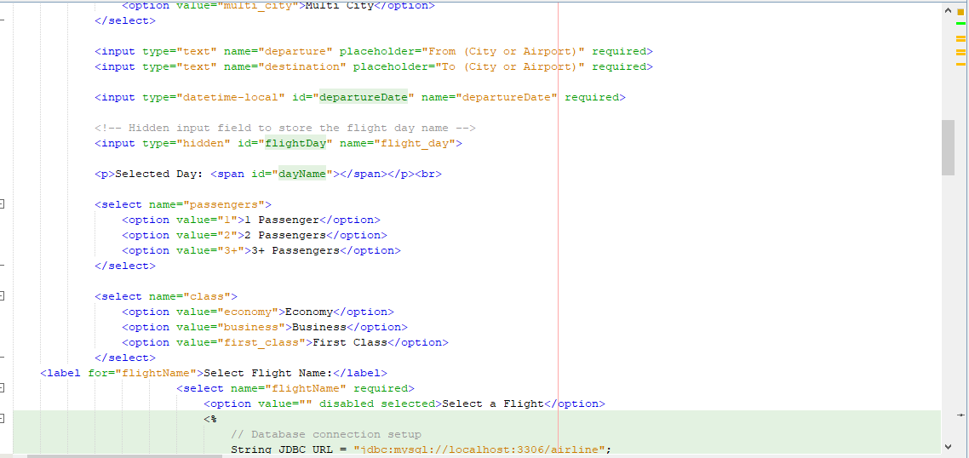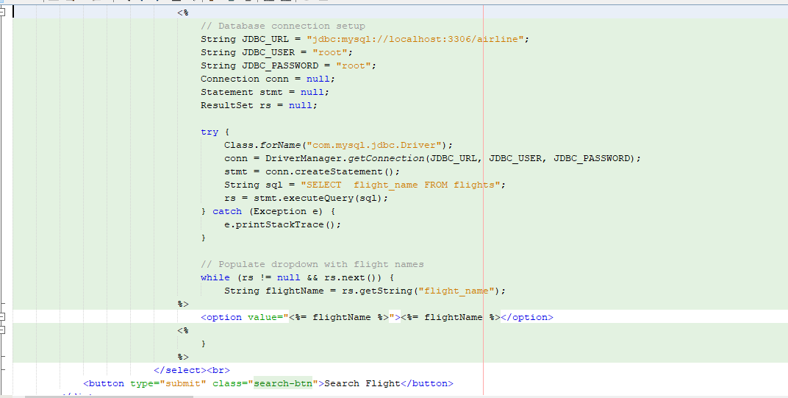

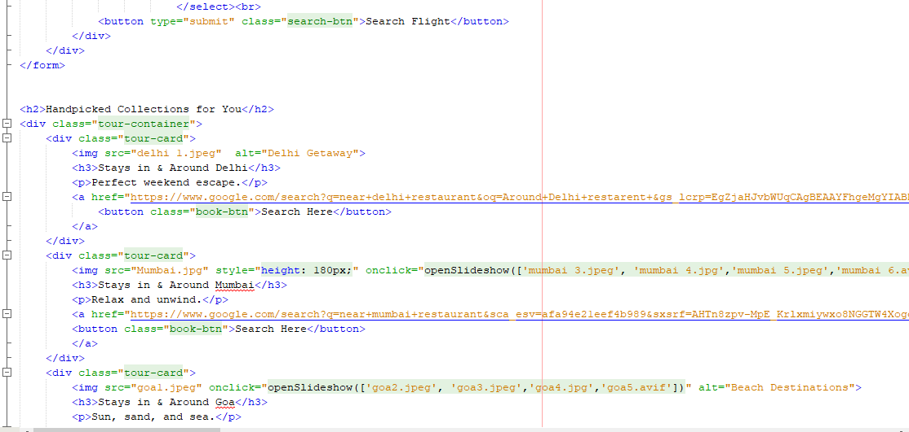

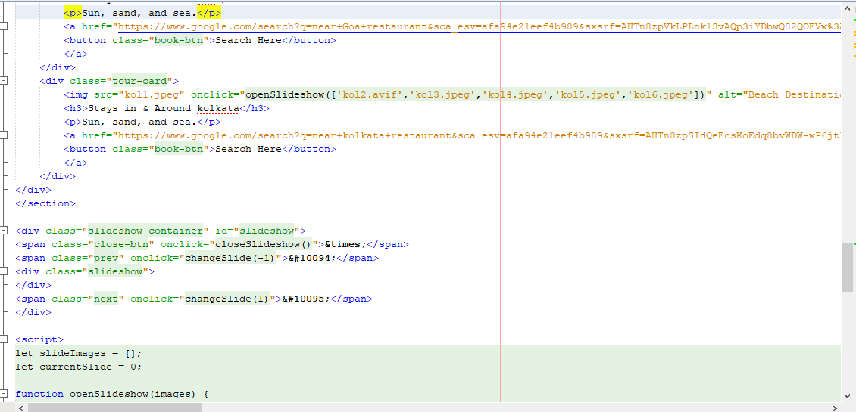

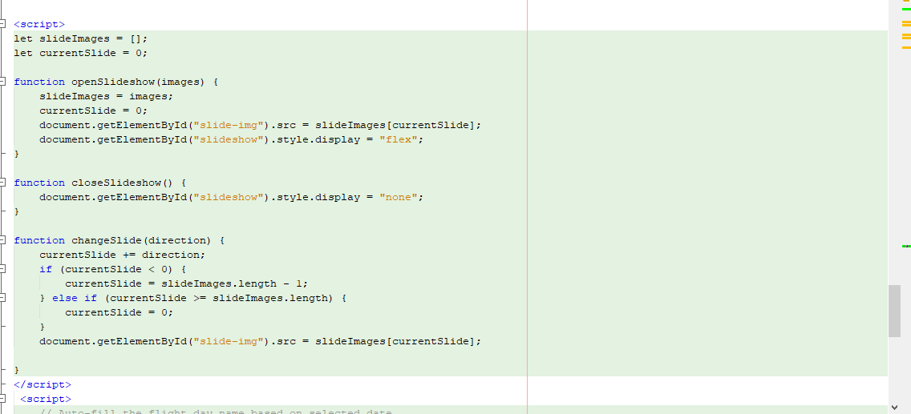

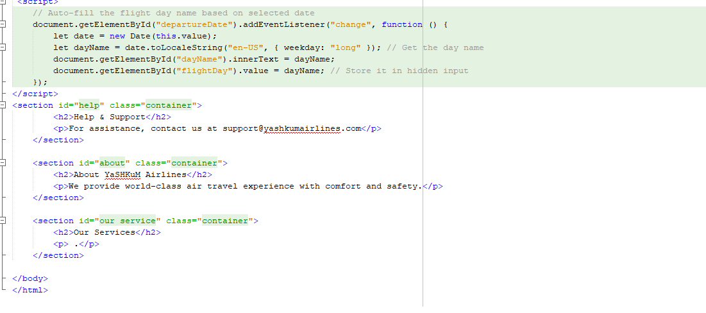

* User Login Page:

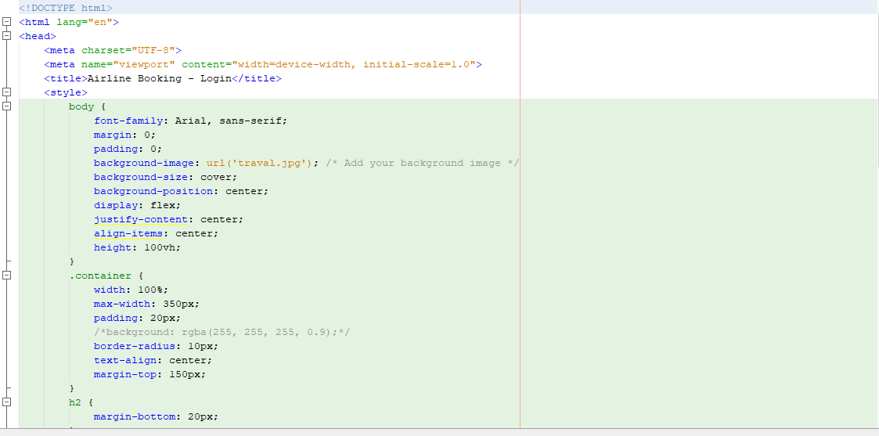

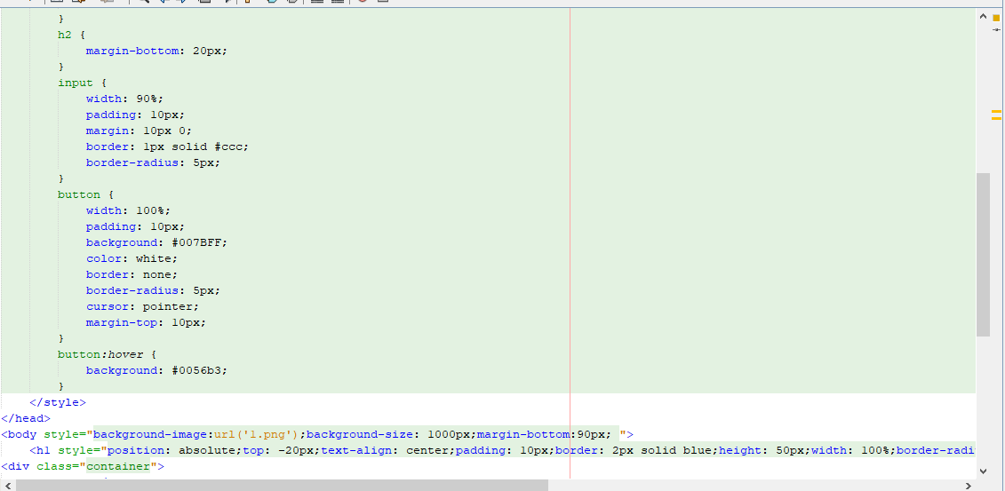

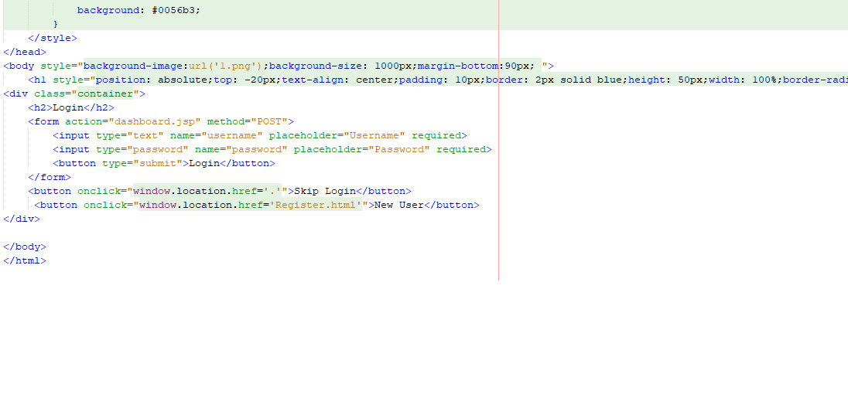

* Admin login page

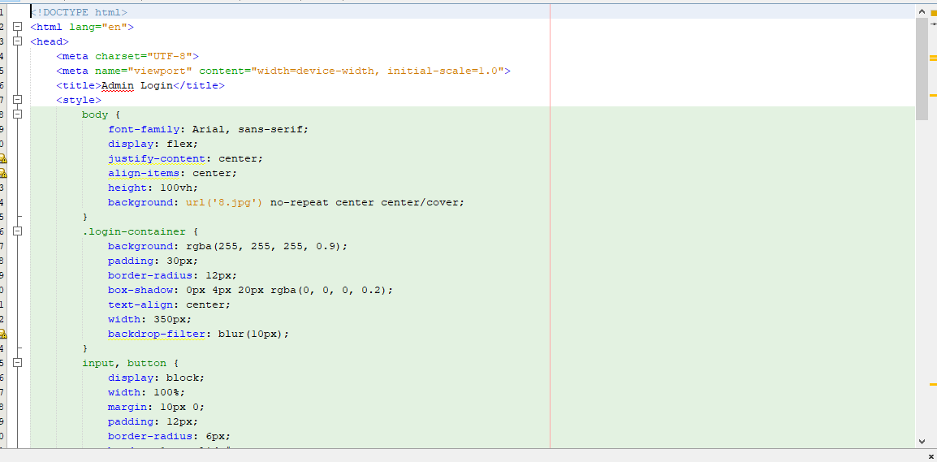

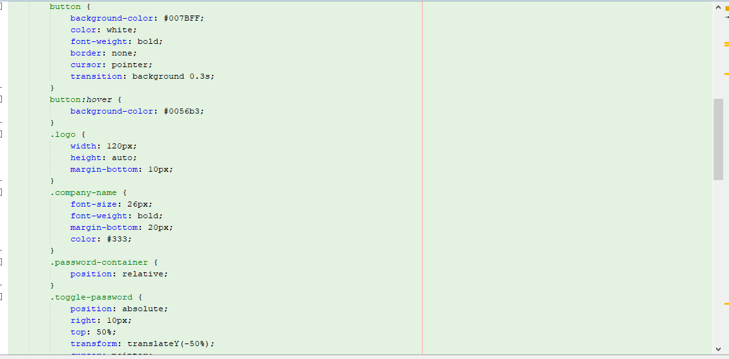

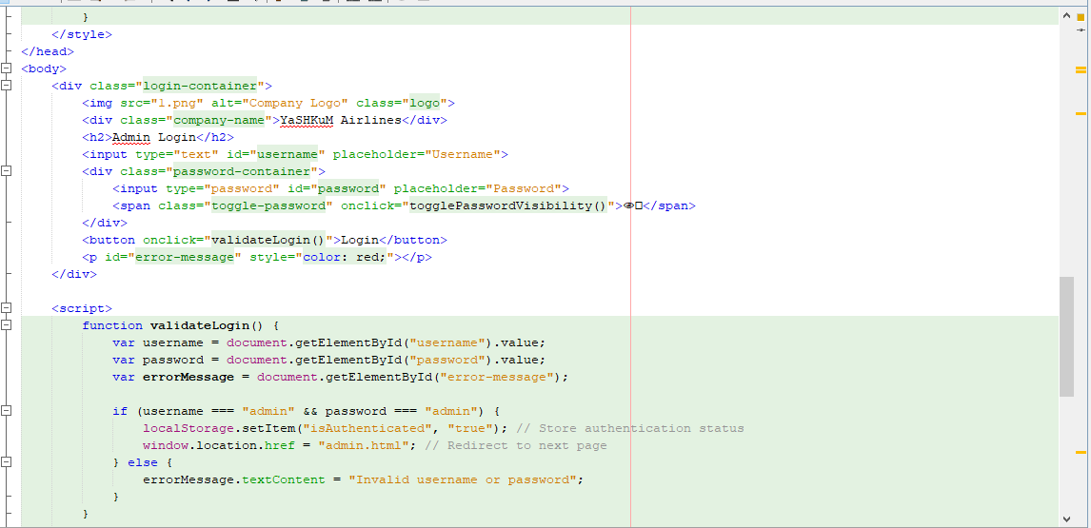

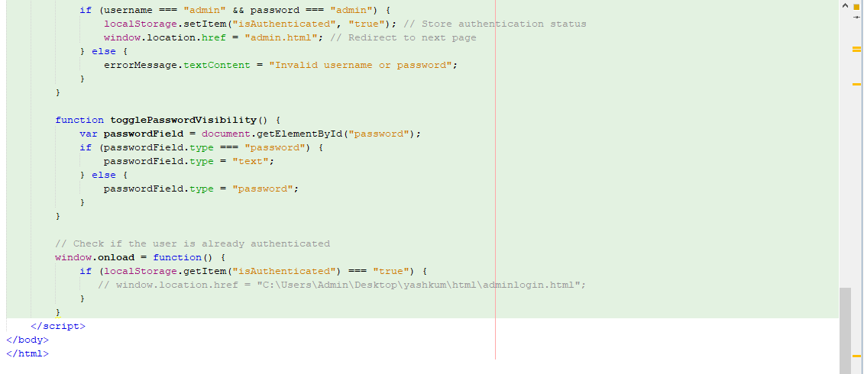

* Admin page:

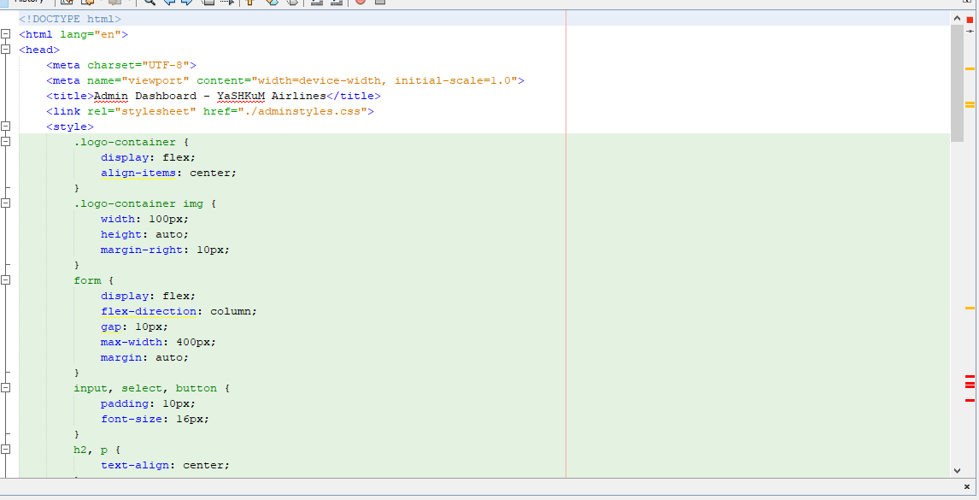

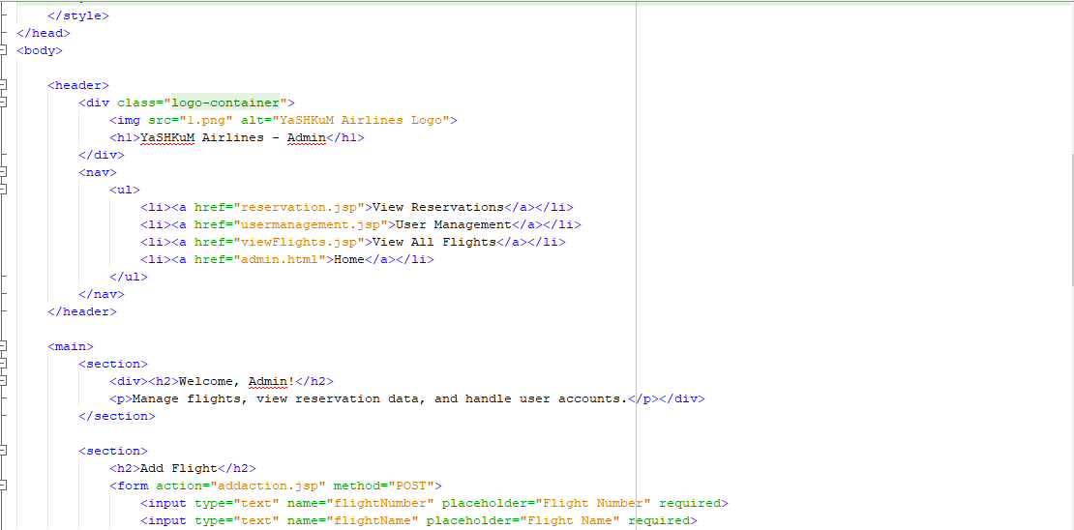

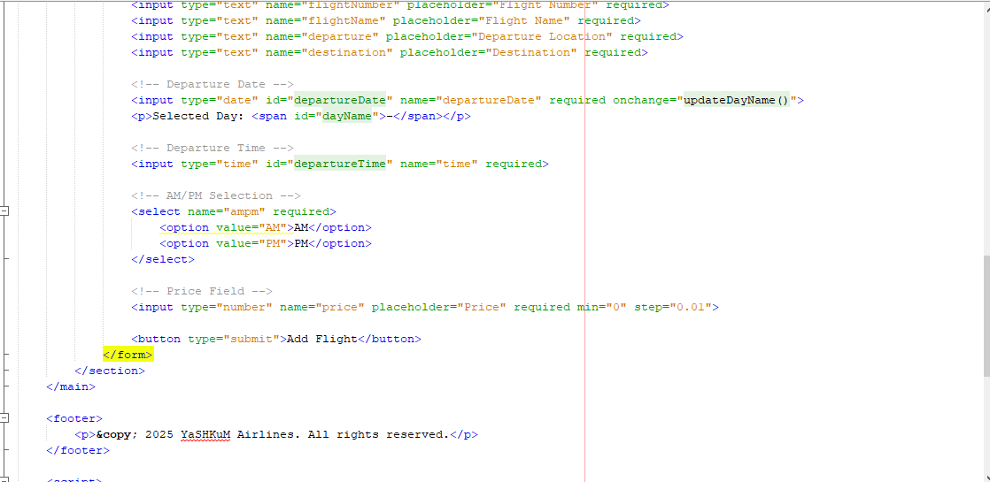

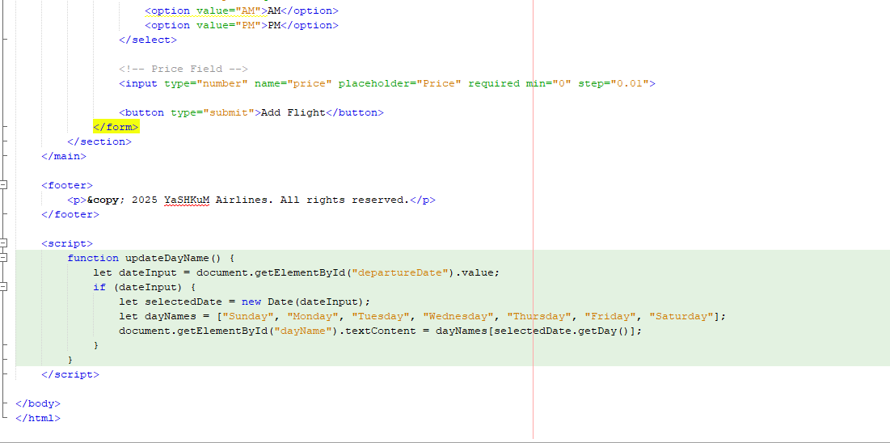

* Flight search:

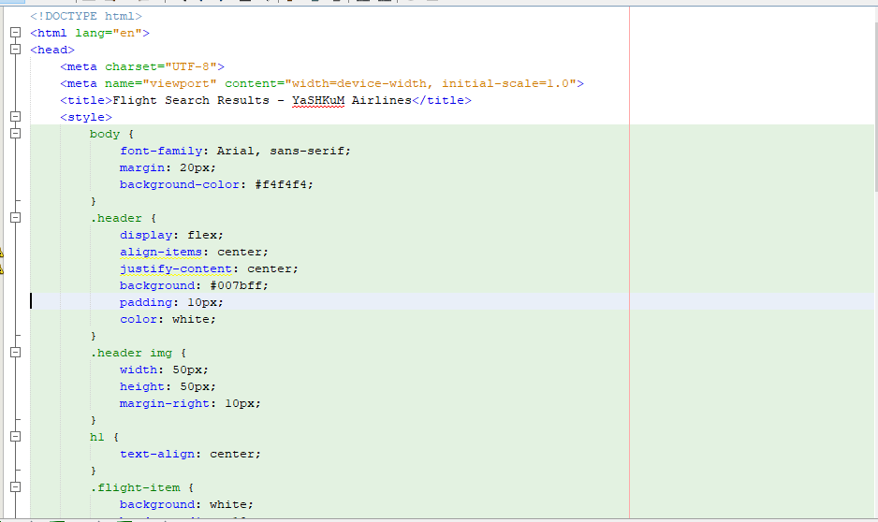

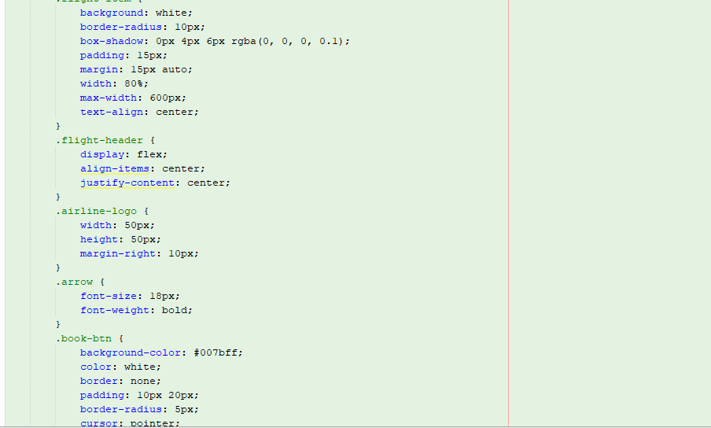

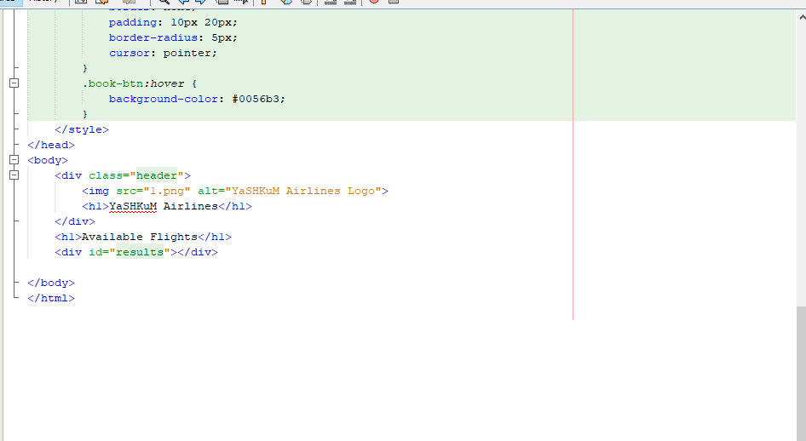

* Passenger’s details page:

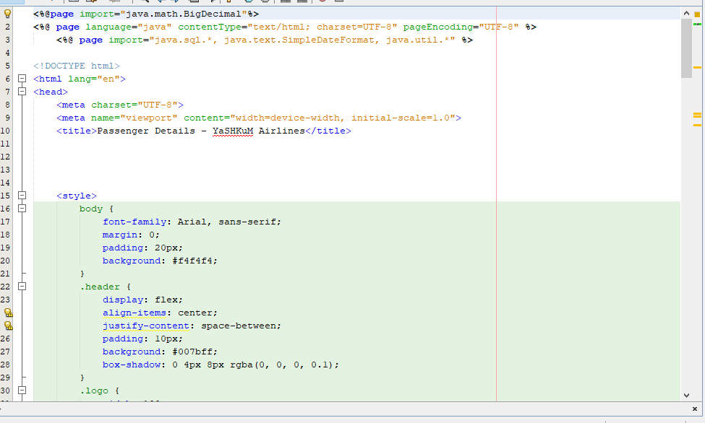

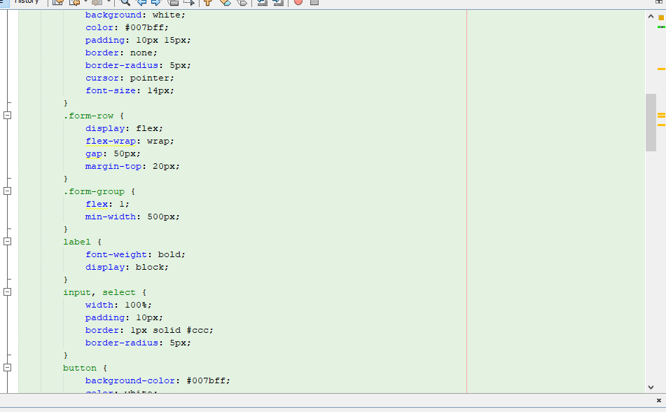

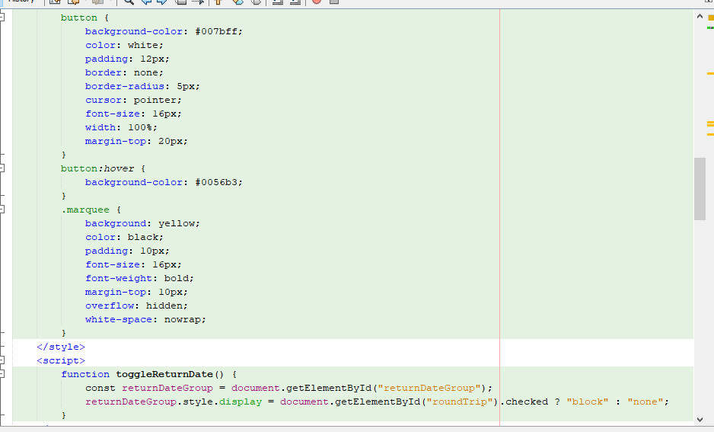

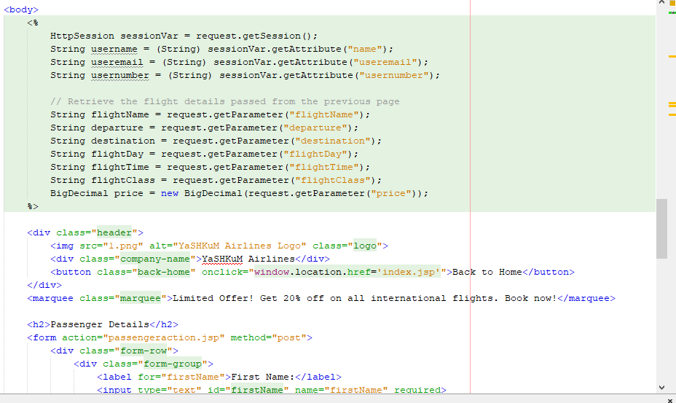

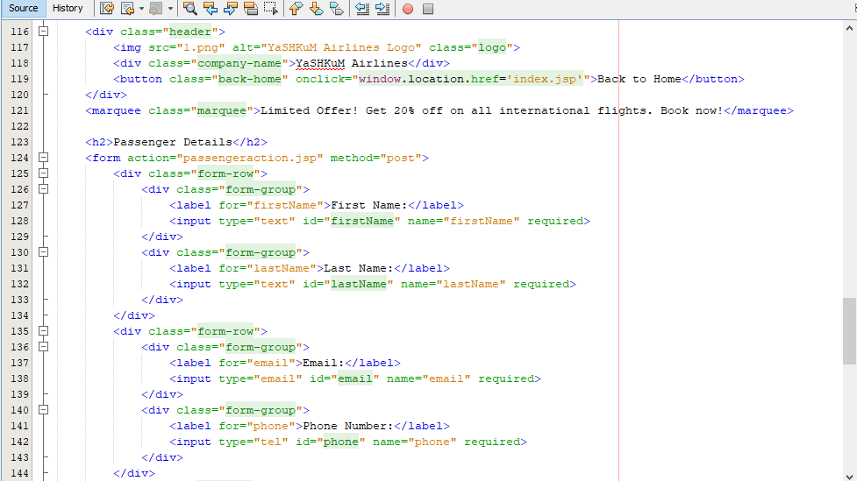

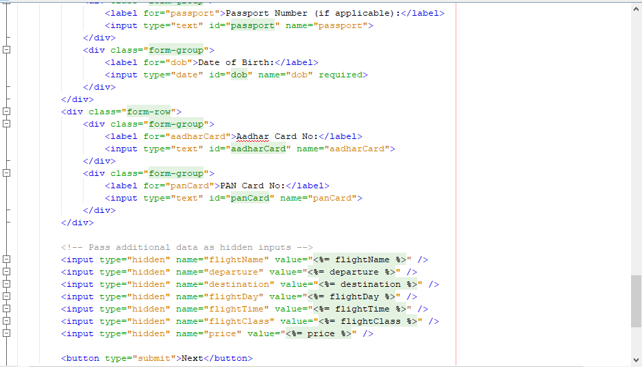

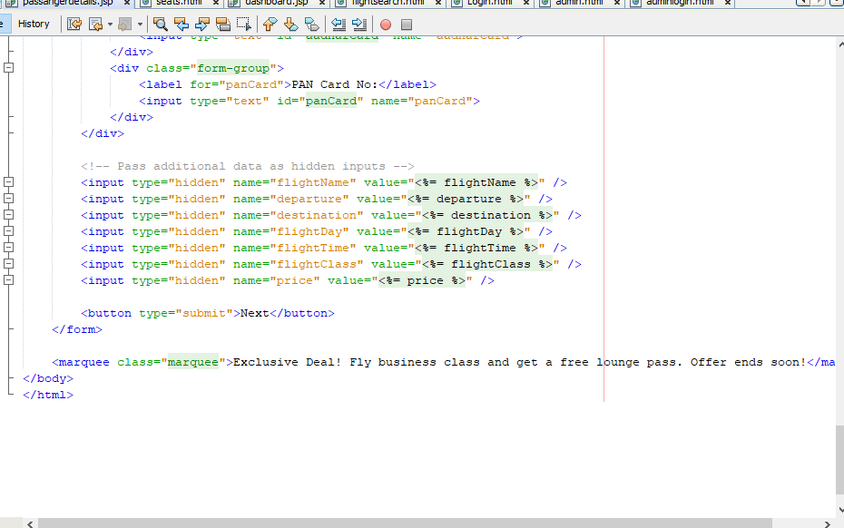

* Seats:

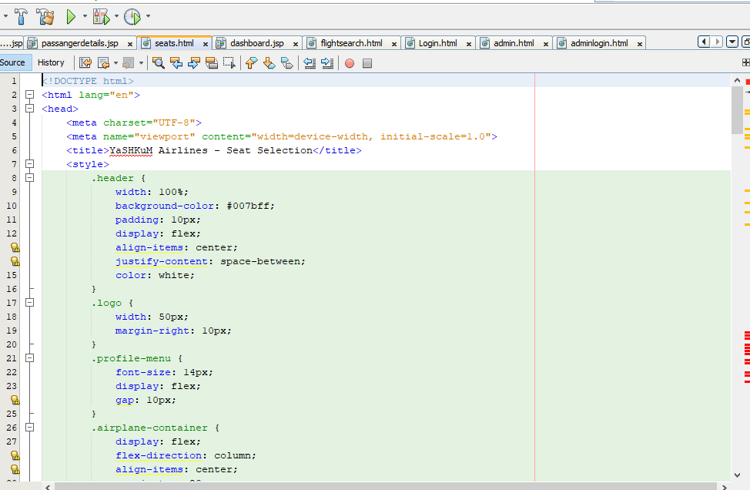

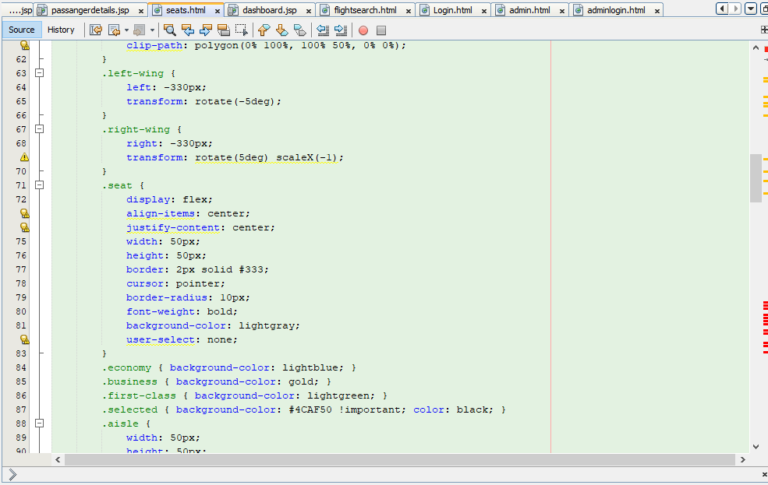

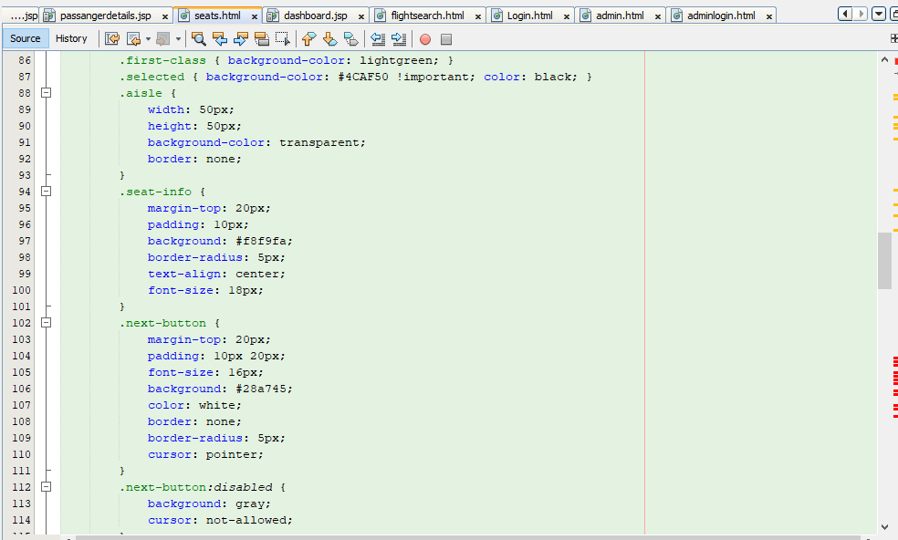

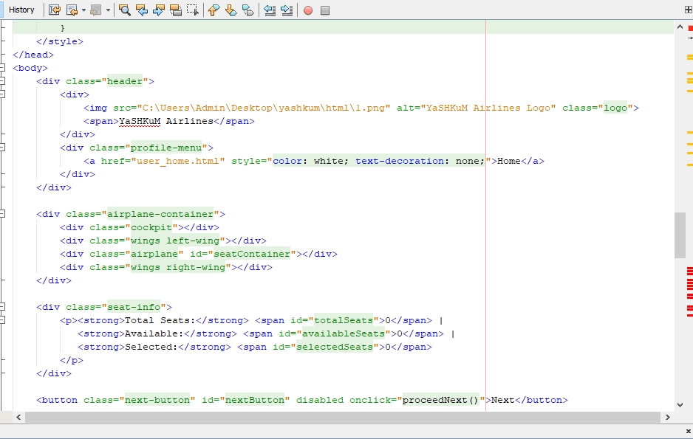

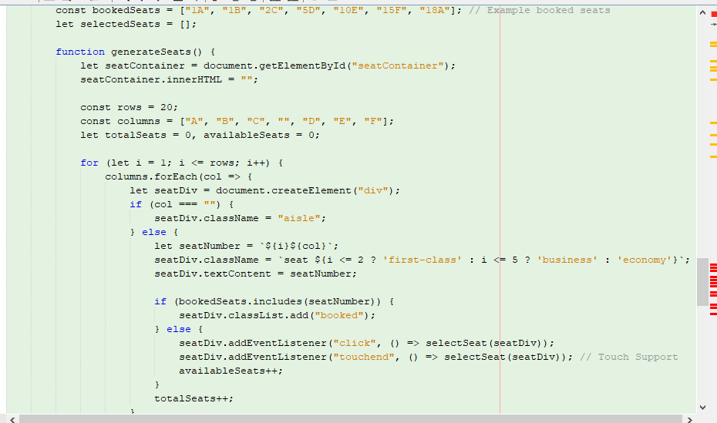

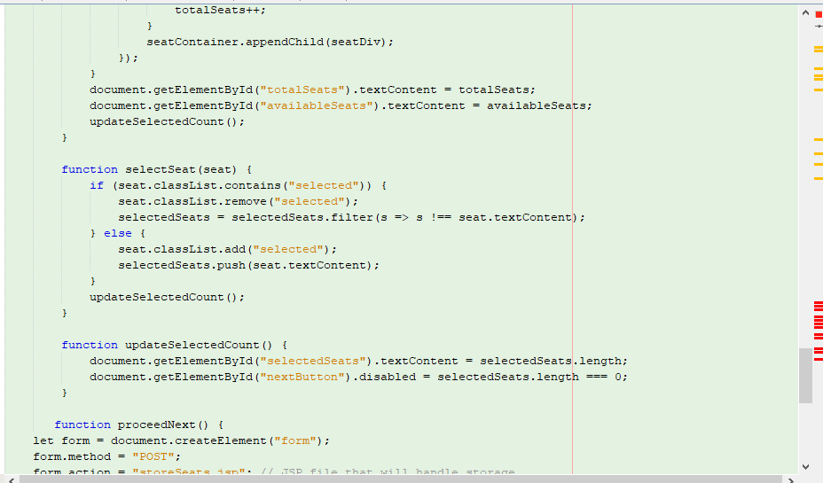

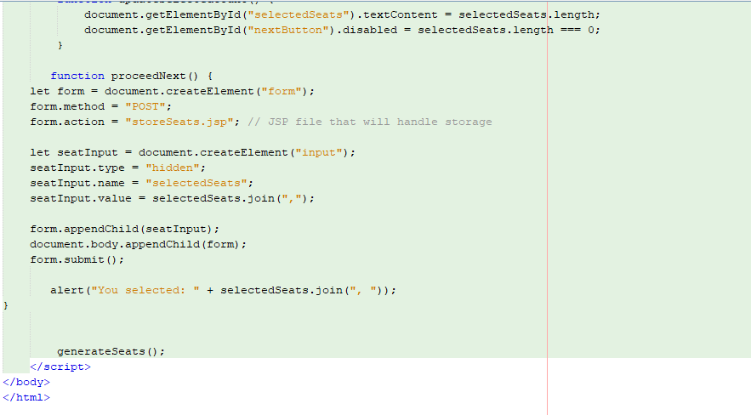

* Payment:

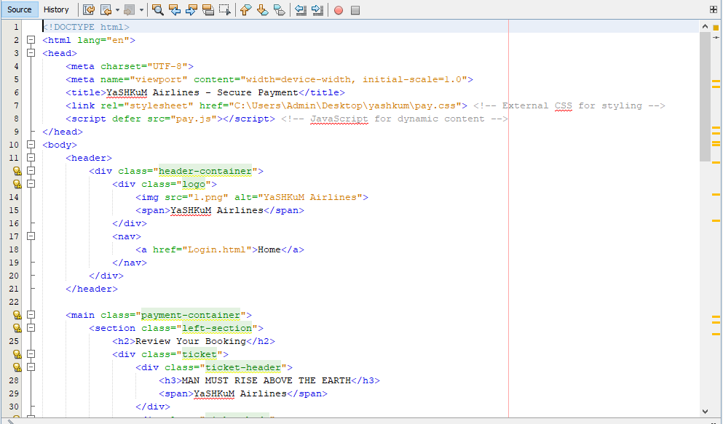

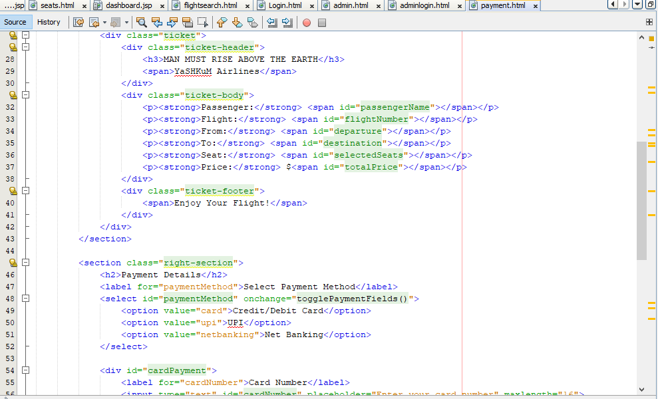

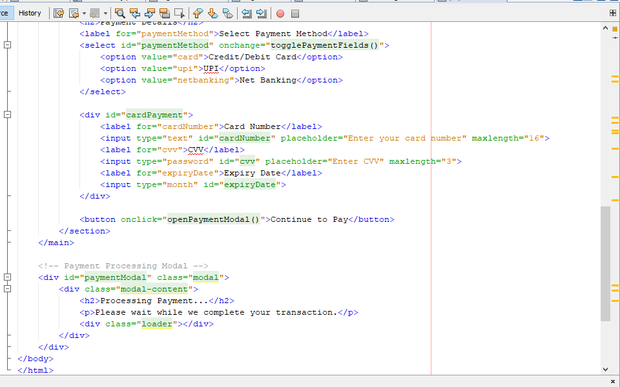

* Received My Ticket In Email:

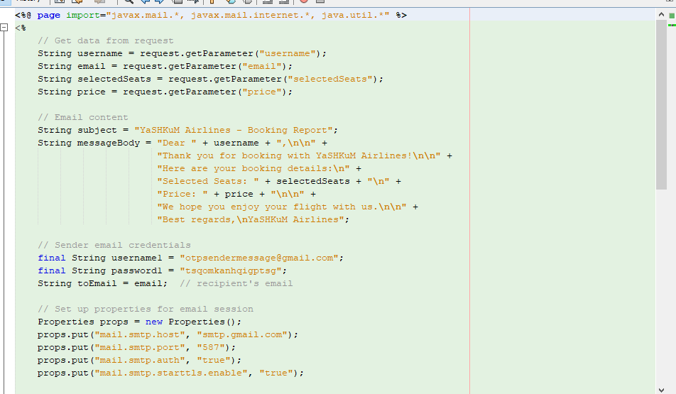

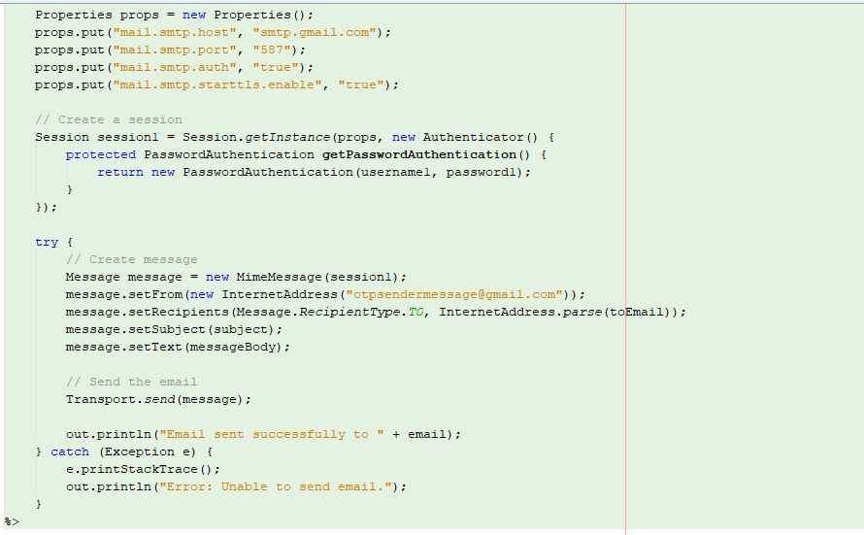

**DATABASE**

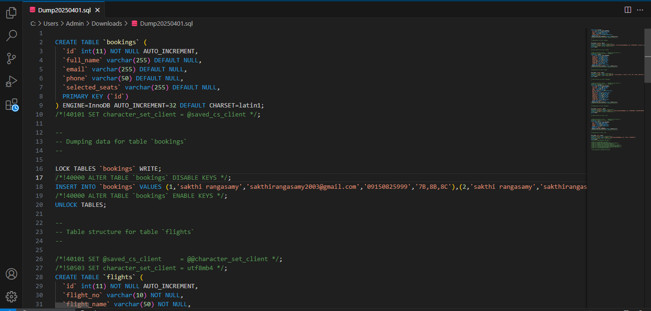

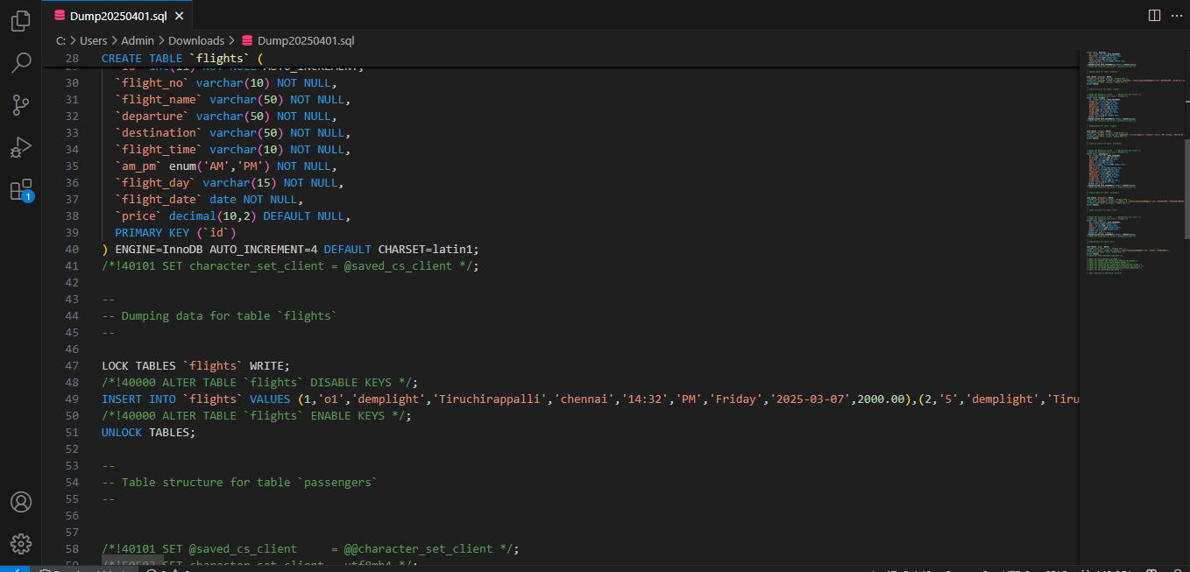

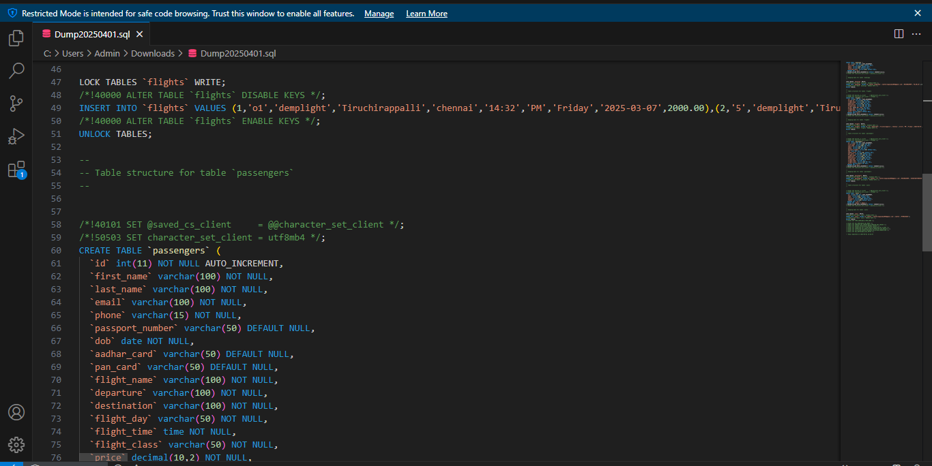

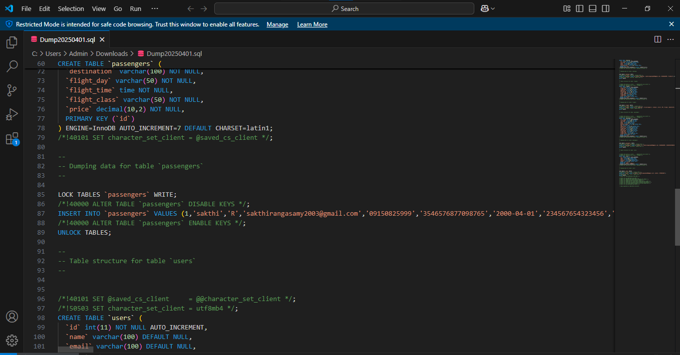

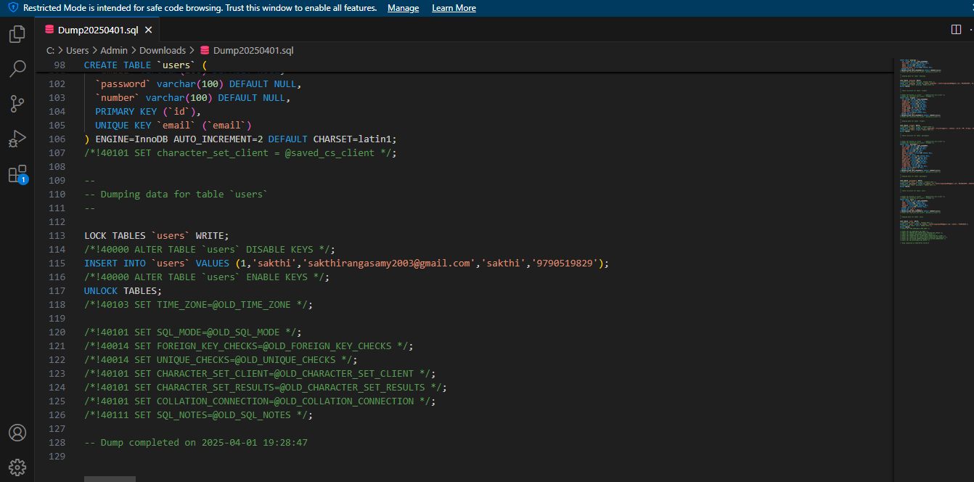

Flights booking details data stored:

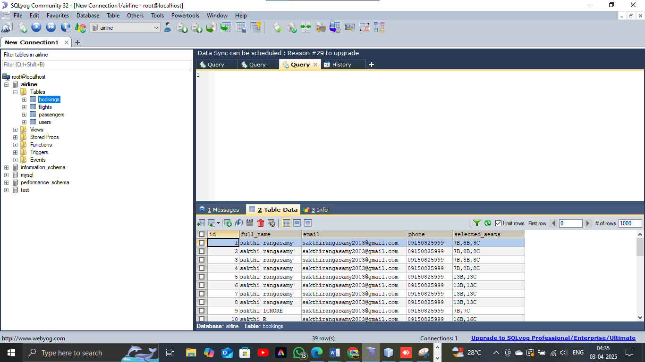

Admin add new flights data stored:

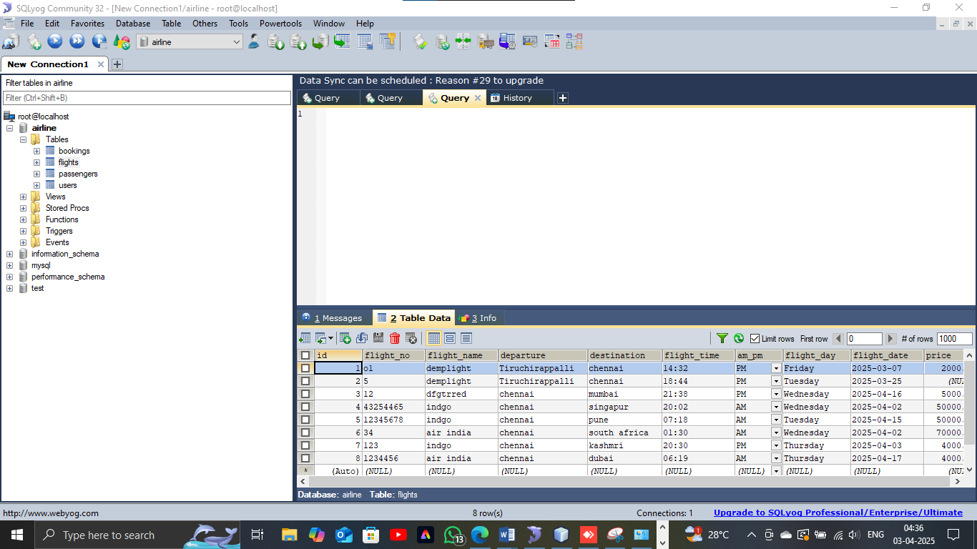

Passenger’s details data stored:

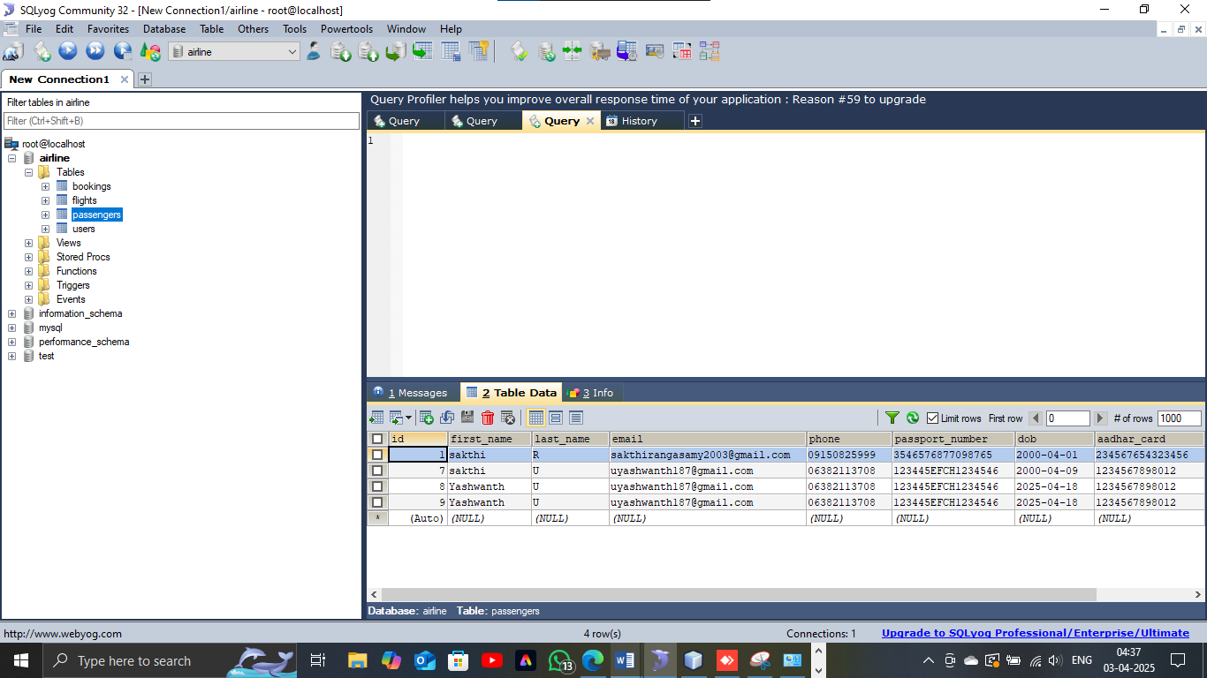

User login details data stored:

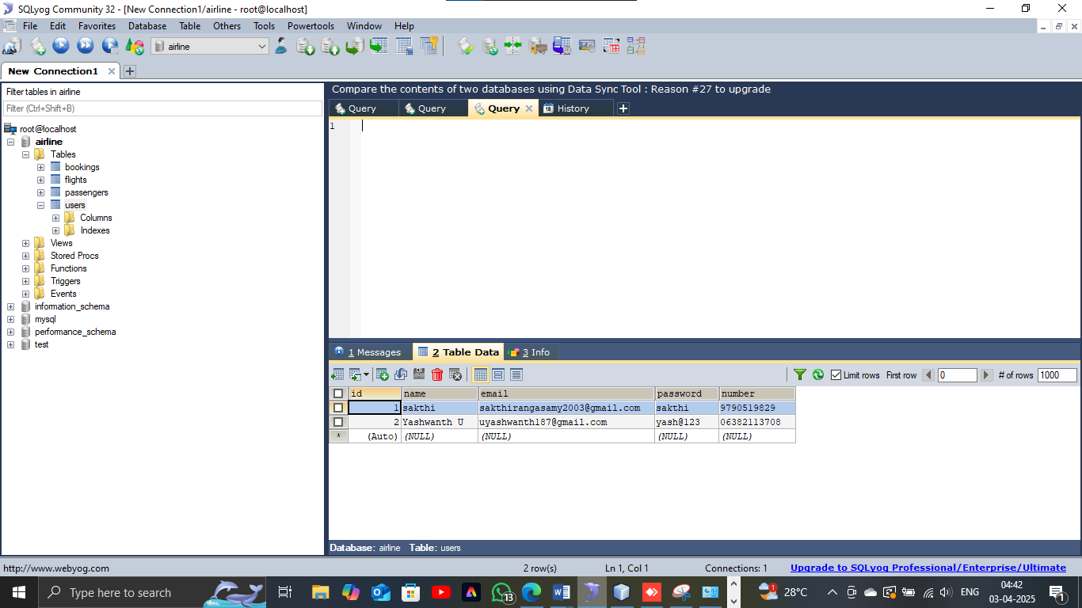

**A VISUAL REPRESENTATION OF A WEBSITE**

1. USER Side Website Home Page

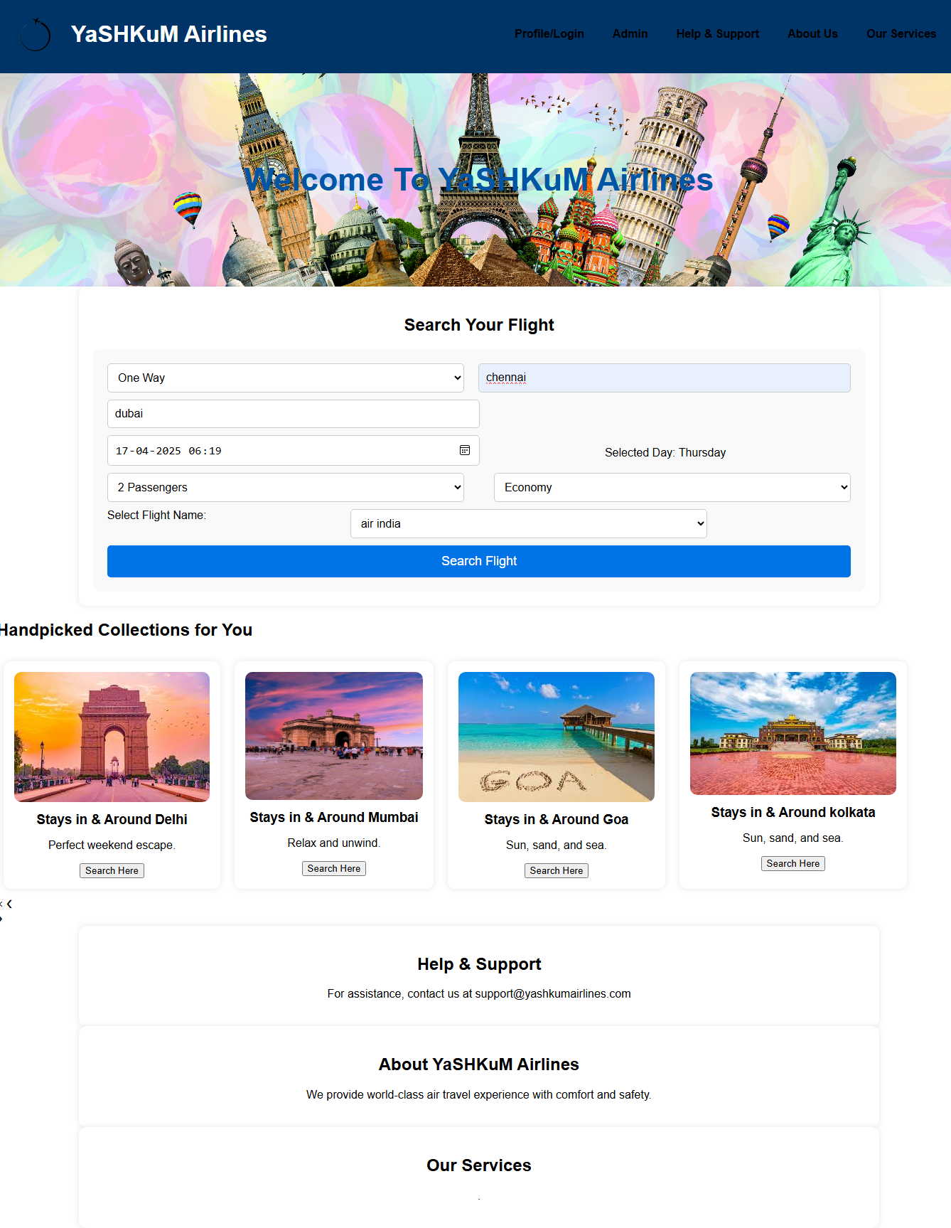

**2. Available flights:**

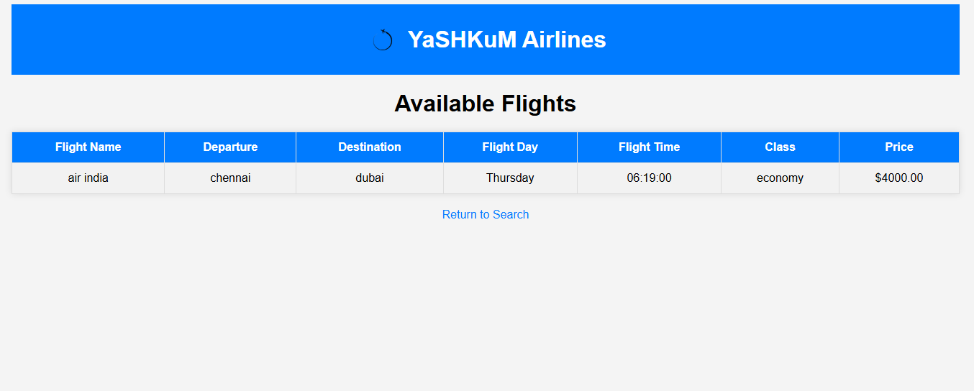

3. User login:

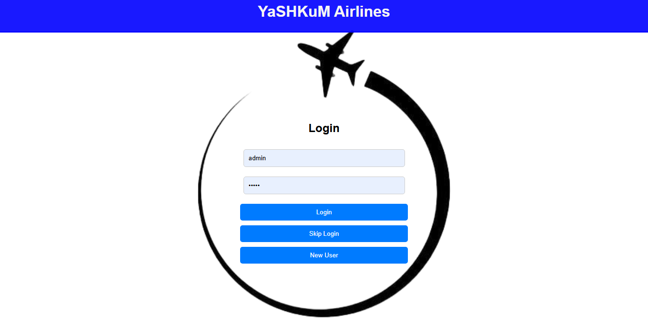

4. After Login Serach That Flights book And Book:

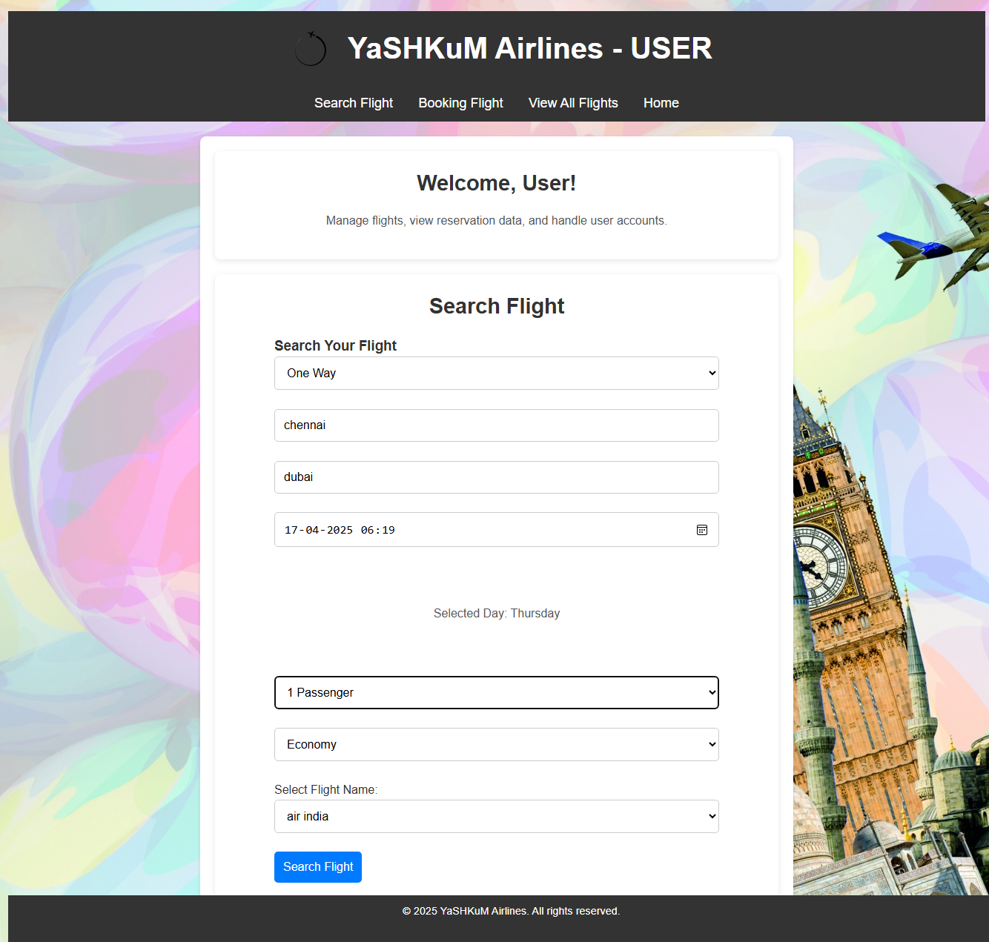

5. Book here:

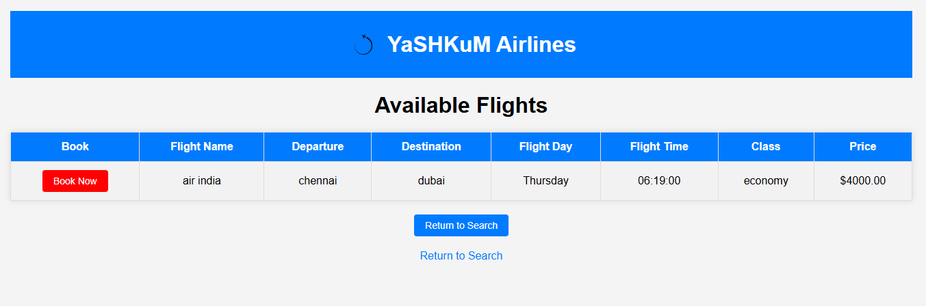

6. Passenger’s details:

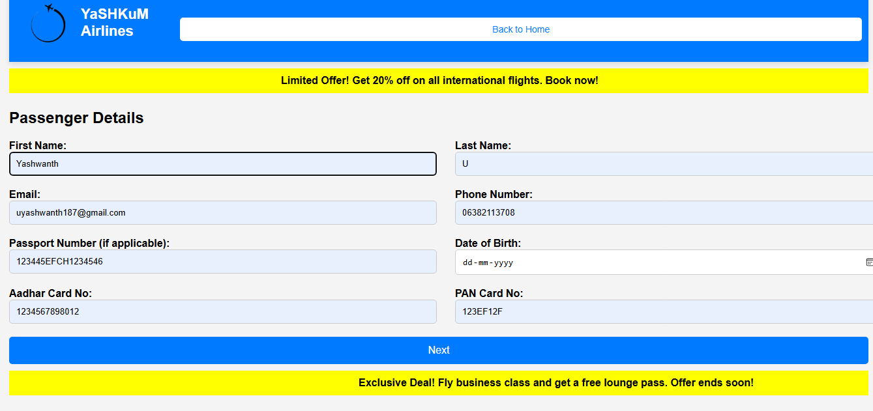

7. Seats:

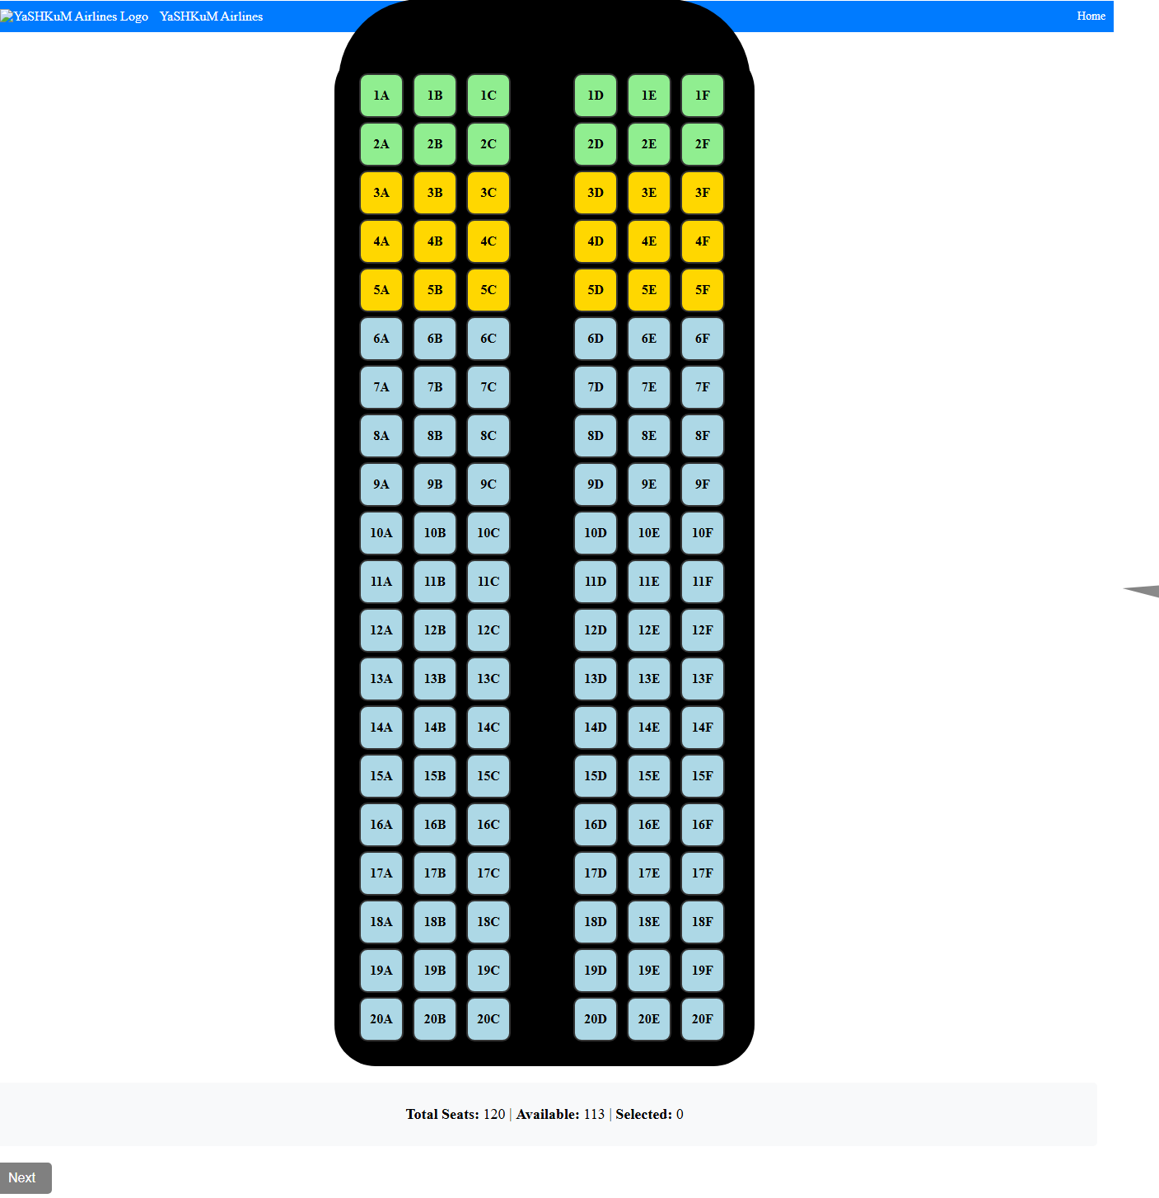

8. Payment Process:

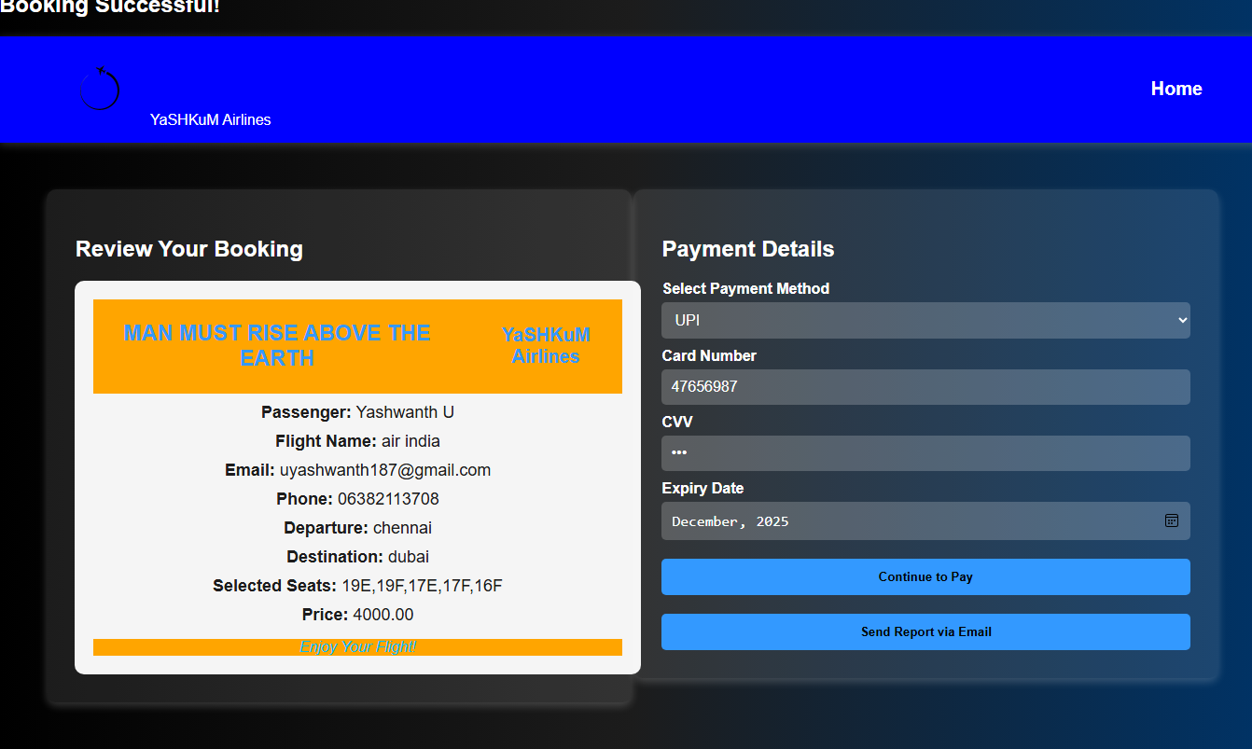

9. Tickets in Pdf:

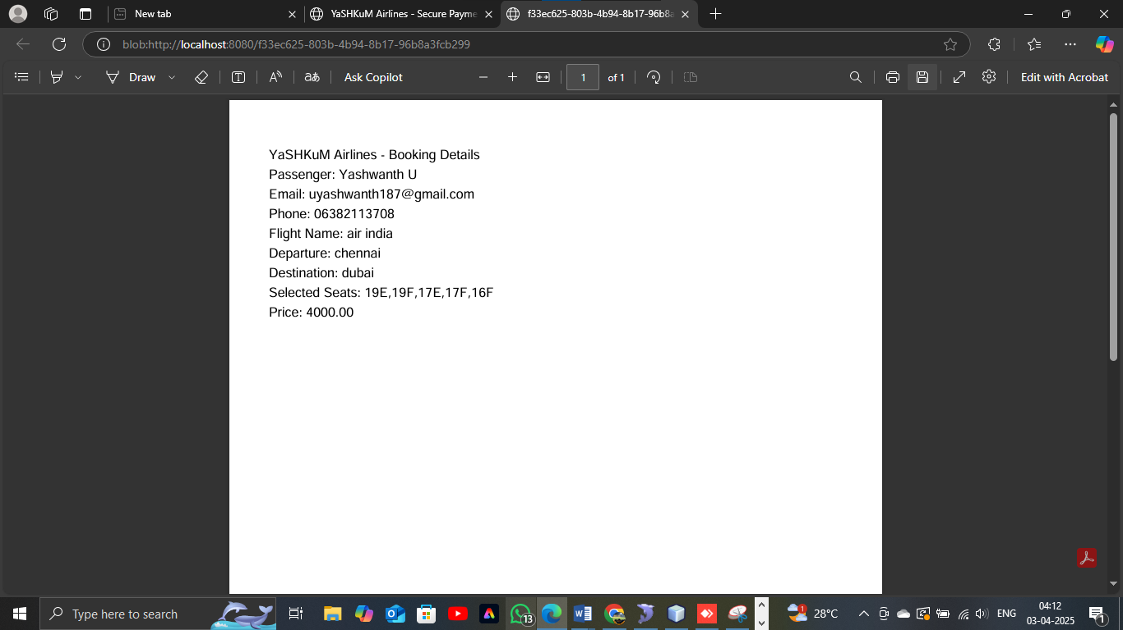

**10.** Tickets in Mail:

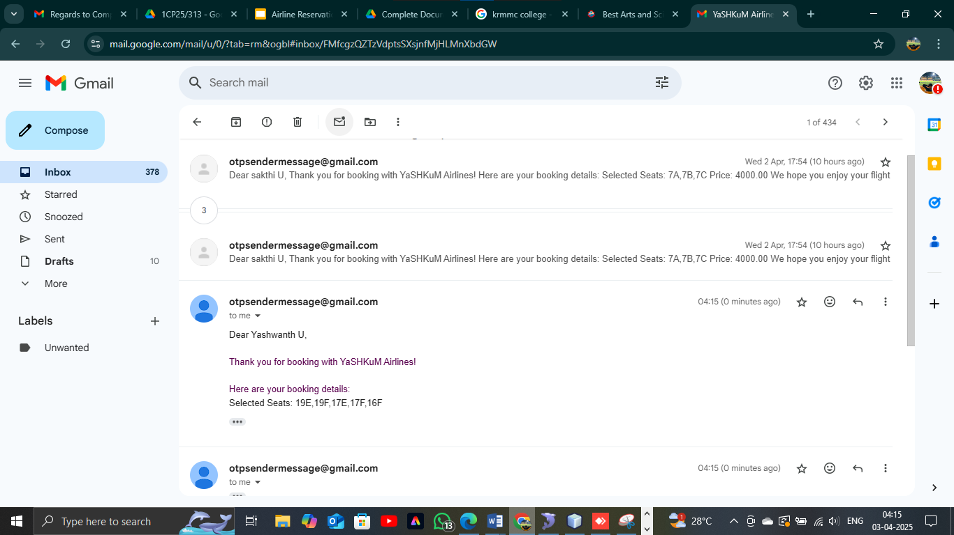

11. ADMIN login:

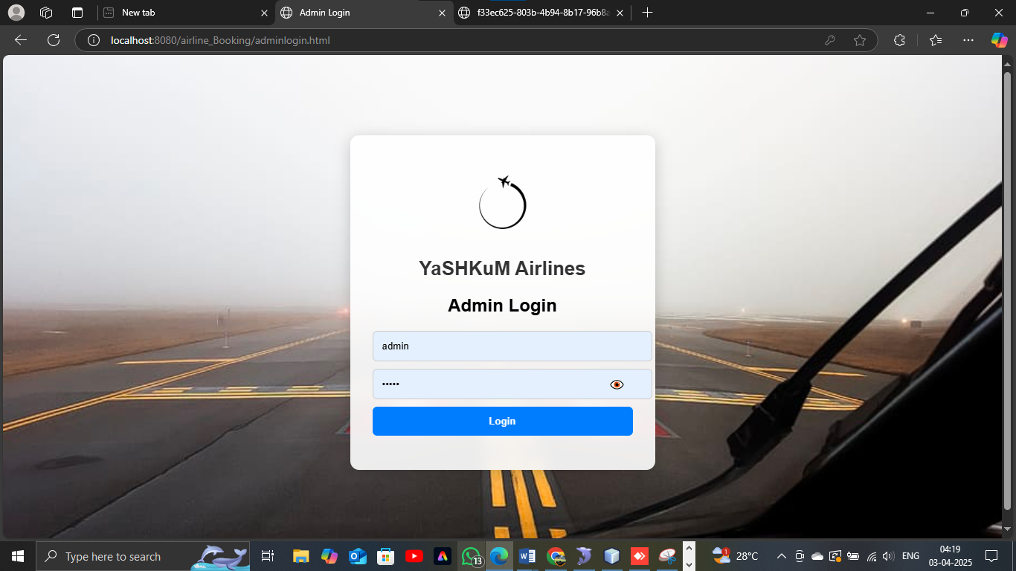

**12.** Admin page:

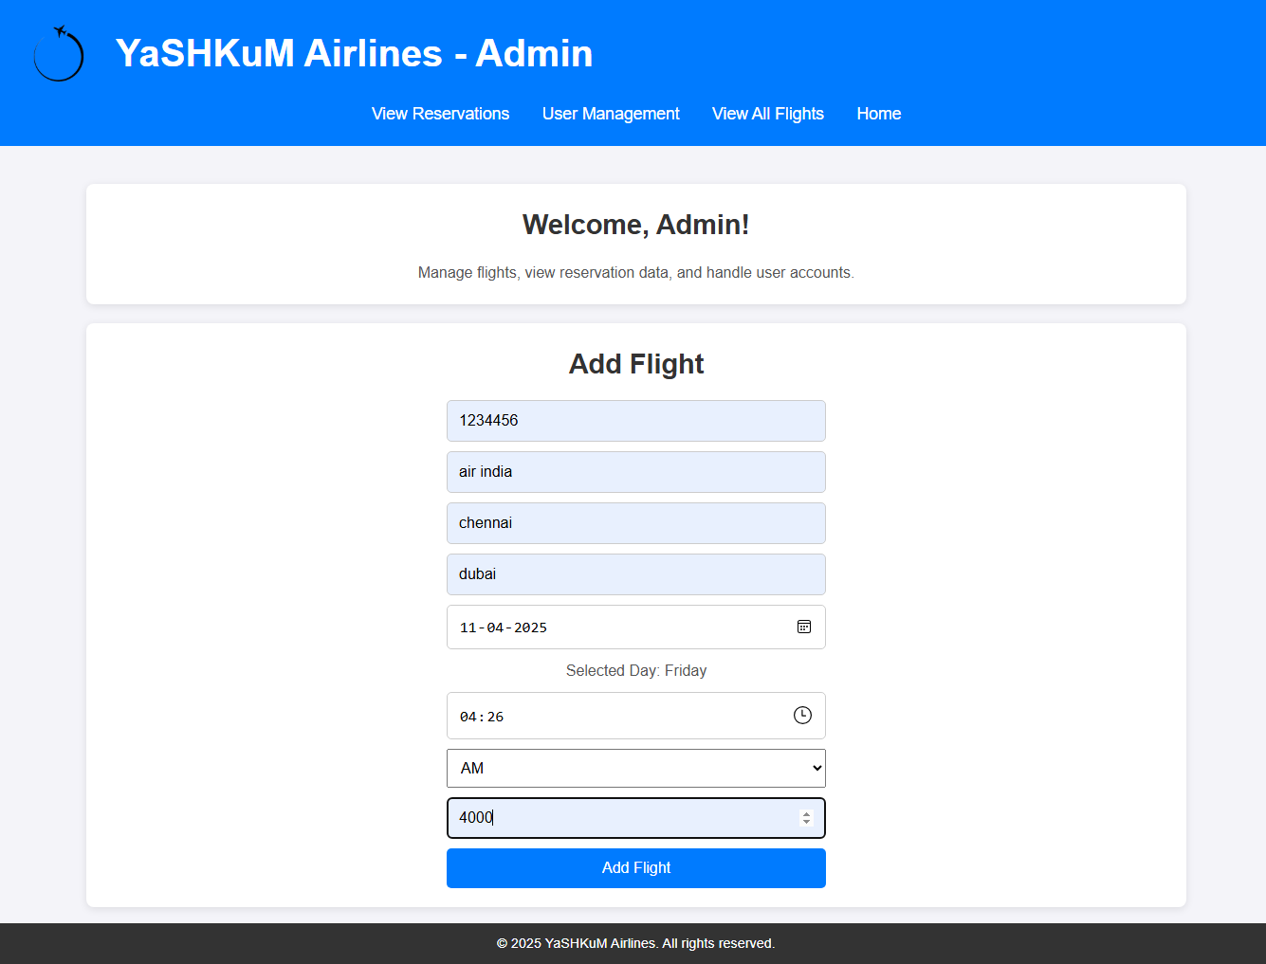

13. View Reservation:

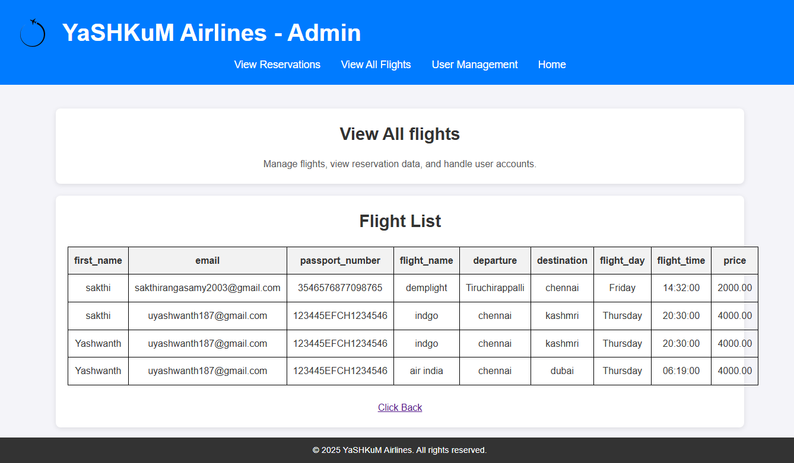

14. User Management:

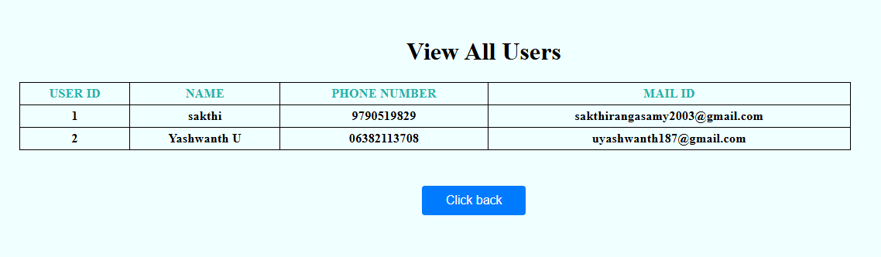

15: View All Flights:

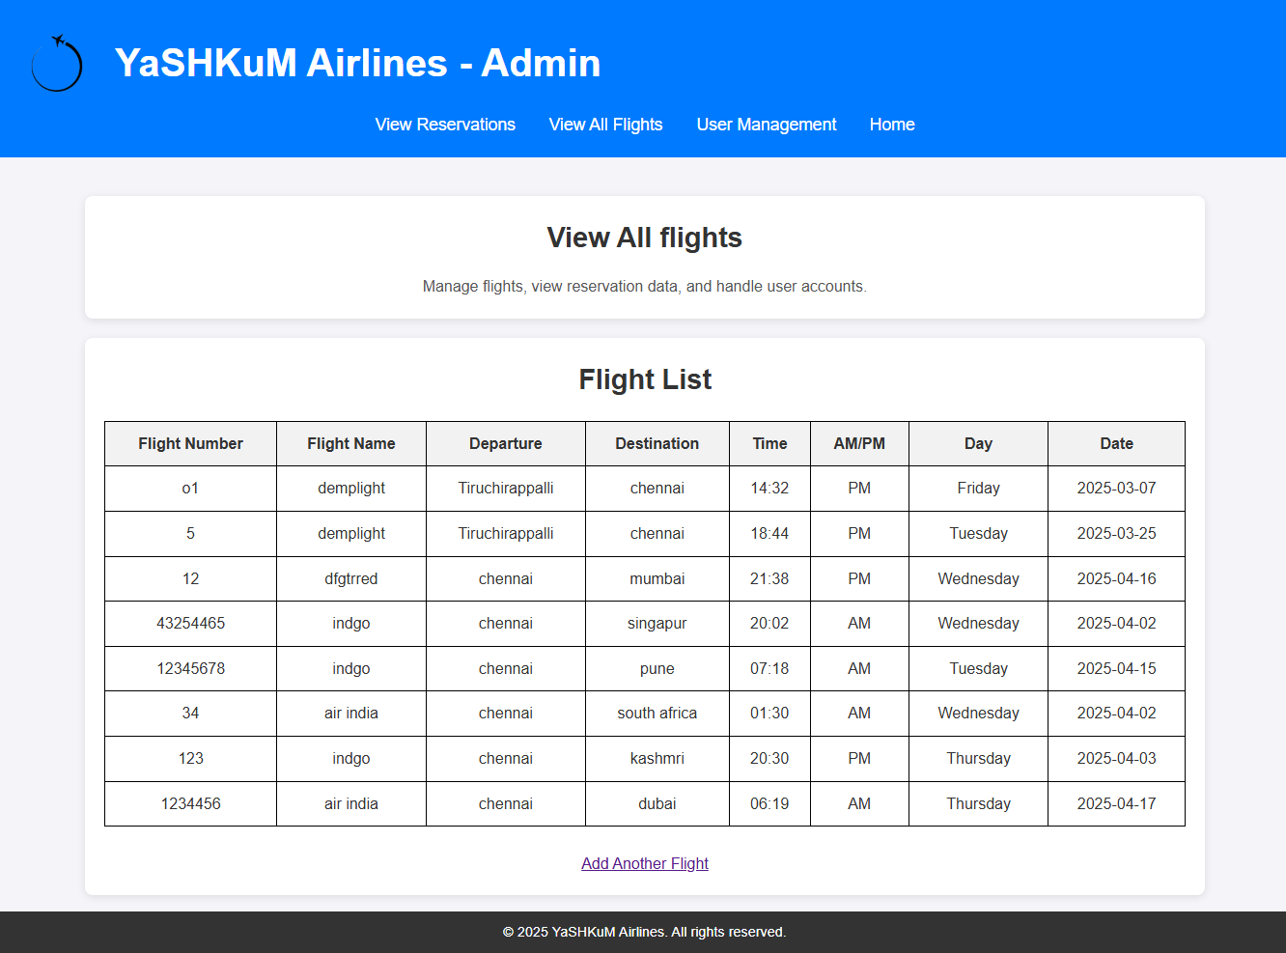

**CONCLUSION**

Airports use a myriad of systems to support their operations. Many of those systems are now incorporating software, database, and network components. They generate both on-demand and regular reports to assist airport management, improve operations and reduce cost at the same time. In order for airports to become more effective and efficient in their operations, they need to understand the competitive advantage of these systems and how to align them together to better serve their stakeholders. This paper provides a possible classification for airport airside management information systems and describes some of their use.

**Application and Future Enhancement**

* It increases the efficiency of your operations
* Take your business global
* It gets smarter insights into your business
* It puts you a step ahead of your competition.

This project can be upgraded by adding more options such as Ticket editing and more admin operations. Payment options and document checking such as ID proofs can be added. Applications can be upgraded by improving performance as per user feedback.